Questions

What is a java script engine and how it works
A JavaScript engine is a kind of process virtual machine that is designed specifically to interpret and execute JavaScript code.
JavaScript engine implements a version of ECMAScript, of which JavaScript is a dialect.
Google’s V8 engine, written in C++, also compiles and executes JavaScript source code, handles memory allocation, and garbage collects leftovers.
Its design consists of two compilers that compile source code directly into machine code:

What is generic’s

Why notify and wait is called from synchronised block

-- http://www.xyzws.com/Javafaq/why-wait-notify-notifyall-must-be-called-inside-a-synchronized-method-block/127

How garbage collection is works.
- Mark-and-Sweep algorithm traverses all object references, with GC roots, and marks every object found as alive.
- All of the heap memory that is not occupied by marked objects is reclaimed. It is simply marked as free, essentially swept free of unused objects.
- All of the heap memory that is not occupied by marked objects is reclaimed. It is simply marked as free, essentially swept free of unused objects.
- https://www.dynatrace.com/resources/ebooks/javabook/the-three-jvms/

Types of heap memories
https://softwareengineering.stackexchange.com/questions/348793/different-types-of-heap-in-java

https://tech.licious.com/demystifying-the-java-heap-and-garbage-collection-a-comprehensive-technical-overview-b907c2d0fad4

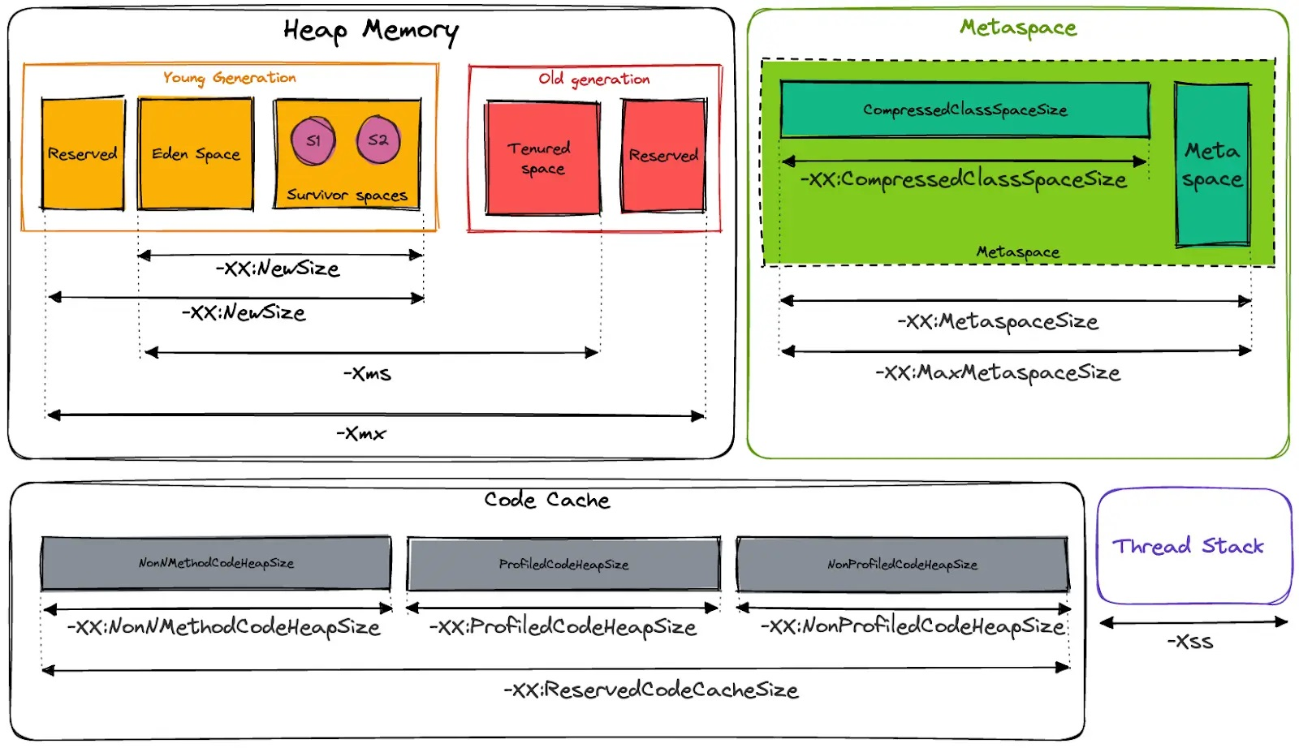

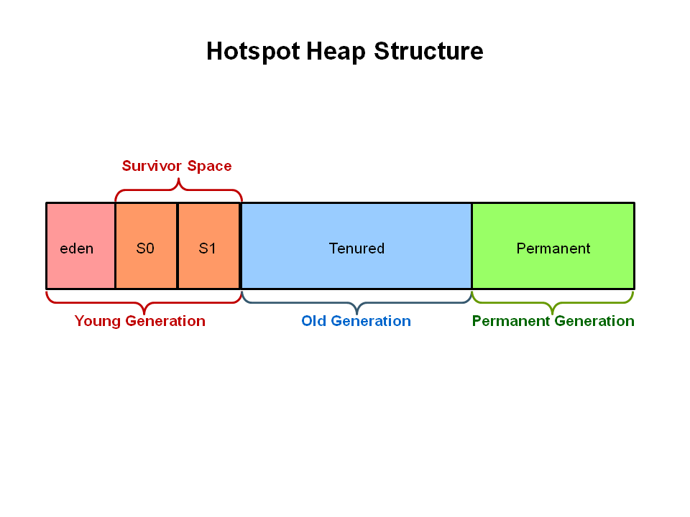

Difference between Json objects and xml objects
Xml: secure.
Json (JavaScript Object Notation.) object:
Objects not light weight and
Support arrays.

Jdk 1.0
Awt, inner class, java beans, jdbc, reflection,
J2se 1.2
Swings, collection
J2se 1.3
Jndi
J2se 1.4
Assert key word, regular expressions, non-blocking IO.
J2SE 1.5
Genarics, autoboxing/unboxing, Enumaration, varargs, Enhanced for loop,
Static import, scanner class for parsing,

Java SE 6
Scripting language support
Jdbc 4.0 support

Java S.E 7
String in switch statement.
Automatic resource management in try-statement
try(FileOutputStream fileOutputStream = new FileOutputStream(“/java7-new-features/src/abc.txt”)){
String msg = “Welcome to java Point”;
Byte byteArray[] = msg.getByte(0);
fileOutputStream.write(byteArray) ;
} catch(Exception exception) {
// sysout(exception);
}

}

Improved type inference for generic instance creation, a.k.a (also know as) the diamond operator.
Allowing underscores in numeric literals.

Java S.E. 8

http://javapapers.com/core-java/java-features-and-history/
- Lambda Expressions
Lambda expression provides implementation of functional interface. An interface which has only one abstract method is called functional interface.
It helps to iterate, filter and extract data from collection.
Advantage: Less coding.
Syntax: (argment-list) -> {body}

() -> System.out.println("Lambdas are great");

- Nashorn JavaScript Engine
  - Java 8 has come up with Nashorn, an engine which enables JavaScript to run on a JVM.
  - It is compatible with Node.js applications also letting the actual Java libraries being called by the code running on the server.
- Parallel operations

- Date and Time API
  - Java.time.LocalDate class
  - Java.time.LocalTime class
  - Java.time.LocalDateTime class
Example java.time.LocalDate.now () (now method which return data in yyyy-mm-dd format)
Java.time.LocalTime.now()
Java.time.LocalDateTime.now()

https://www.journaldev.com/2800/java-8-date-localdate-localdatetime-instant

- Default Methods
  - We can declare default method in an interface
  - When we use "default" keyword with a method is known as default method in java interface.
  - Java default method is a non-abstract method and we can declare default method with body.
  - We can override default method in java.
  - We can keep both abstract and default methods in an interface and static method also.
  - We can define static methods in interfaces.
Interface myInterface {
default void display () {
//default method
System.out.println ("This is default method in java 8");
}
//declaring static method
static void watch() {
System.out.println ("This is static method in java 8");
}
// MyInterface. Watch(); //calling static method of interface
Difference between Abstract class and Interface
Abstract Class
We can't achieve fully abstraction through abstract class.
We can put the constructor in an abstract class.

Java 8 Interface
We can achieve full abstract through java 8 interface.
We cannot put the constructor in interface.

- Type Annotations
- Concurrent Accumulators
- Pipelines and Streams
  - Java.util.stream represents a sequence of elements or objects on which one or more operations can be executed. Stream operations are either terminal or intermediate.
  - Terminal Operations return a result of certain type.
  - Intermediate Operations return stream itself where you can make multiple calls in a row.
  - Streams are created on a java.util.Collection source like List or set. Maps are not supported.
  - The stream interface supports the map/filter/reduce patterns and executes lazily, forming the basis (along with lambdas) for functional-programming style in java 8.
  - Collection is a in-memory data structure to hold elements and all the elements will be populated before we start using the collection. Whereas java stream starts computing on-demand basis.
  - Java stream does not store data and operates on the source data structure and produces stream of the data elements where we can perform operations.
  - Java stream operations use functional interfaces, which is suitable functional programming using lambda expression.
Stream API Operations
stream() Returns a sequential stream with the collection as its source.
List<String> stringsList= new ArrayList<>();
stringsList.add("donkey");
stringsList.add("ant");
stringsList.add("ball");
stringsList.add("apple");
stringsList.add("banana");
stringsList.add("cat");
stringsList.add("bell");
stringsList.add("dog");

stringsList
.stream()
.filter((s) -> s.startsWith("a"))
.forEach(System.out::println);
parallerlStream() Returns a possibly parallel stream with the collections as its source
Operations on Parallel Streams are executed on multiple threads concurrently where Sequential operations can be performed on a single thread only.
int max = 1000000;
List<String> values = new ArrayList<>(max);
for (int i = 0; i < max; i++) {
UUID uuid = UUID.randomUUID();
values.add(uuid.toString());
}
long count = values.parallelStream().sorted().count();
System.out.println(count)

- PermGen Error Removed
  - PermGen space is supressed by a new space called Metaspace in java 8
  - You can specify the maximum Metaspace Size WITH THE ANALOGOUS –Xx:MaxMetaspaceSize=<NNN> option; however, the default is recommended for most deployments
- TLS SNI

Java 8 New Feature with Method Reference
Is used to refer method of functional interface and to make program or code simple or clear.
You can use method reference instead of lambda expression.
It is shorthand notation of lambda expression to call any method.
:: operator is used for method reference in java programs.
Reference to instance method
Object :: instanceMethod
Reference to static method
Class :: staticMethod
Reference to an instance method of an arbitrary object of a particular type.
Class :: instanceMethod
Reference to constructor
Class :: new
Interface Demo {
void show();
}
public class Test {
public void display() {
sysout(“ï am instance method”);
}
Public static void main(String args[]) {
Test t = new Test();
Demo d = t :: display;
d.show();
}
}

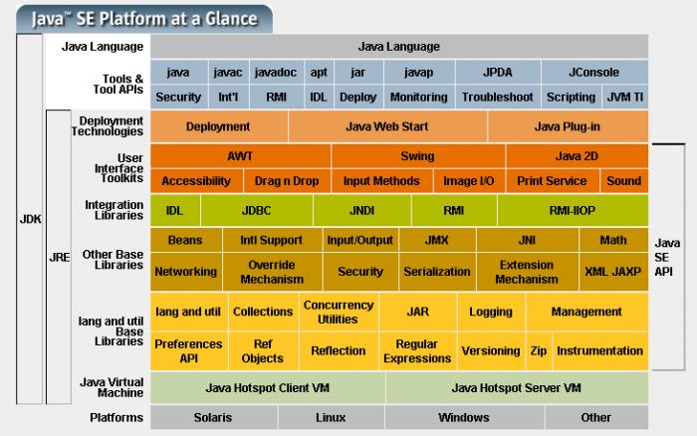
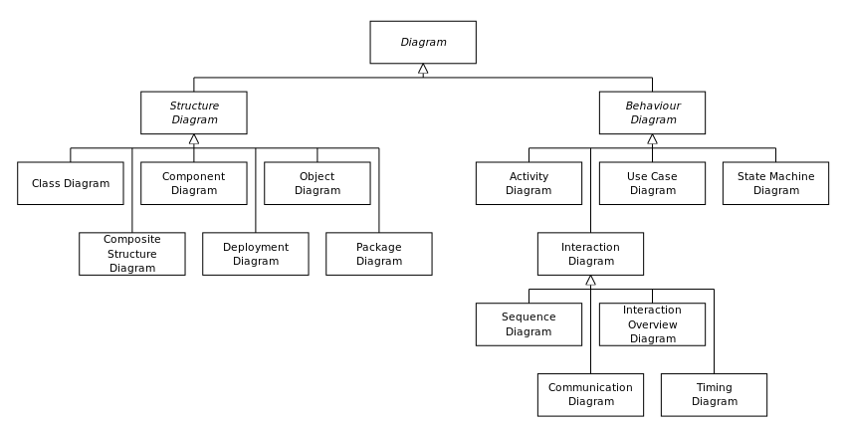

Class diagrams
Is a Unified Modelling Language. It represents static structure
diagram that describes the structure of a system by showing the systems
class, their attributes, operations and relationship among the objects.
Interface can have class diagrams.

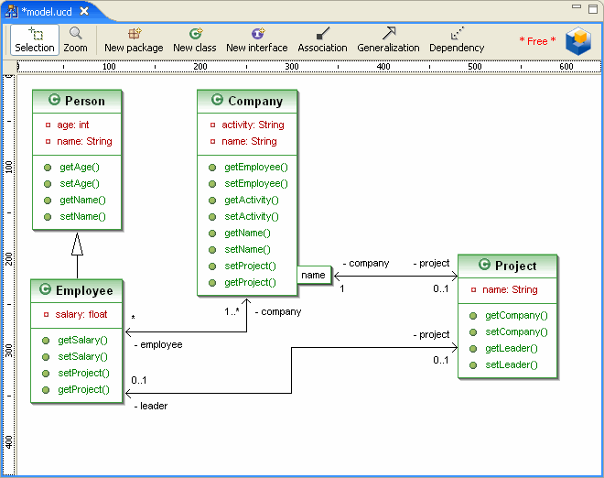

Sequence diagram
UML Sequence diagrams models the flow logic within system
in a virtual manner, enabling you both to document and validate your
logic, and are commonly used for both analysis and design purpose.

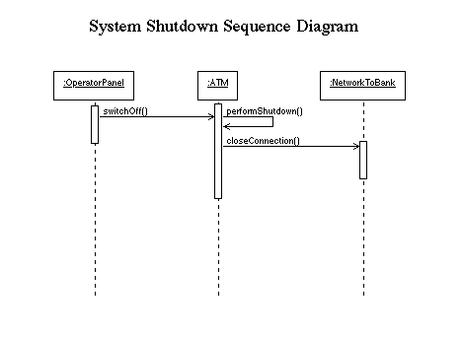

Flow diagram
A flow diagram is a diagram represent some kind of flow. The most known
Is the flowchart. Flow charts represent an algorithm, a process, or the step-by-step solution of a problem.

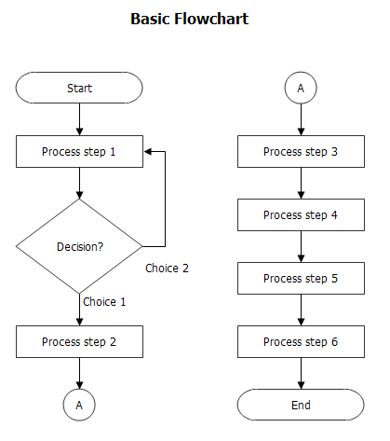

E-R diagrams
An entity-relationship diagram (ERD) is a data modelling technique that graphically illustrates information system’s entities and the relation-
ships between those entities. An ERD is a conceptual and represent model of data used to represent the entire framework infrastructure.

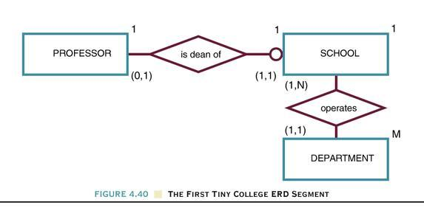

Use case Diagram
A use case methodology used in system analysis to identify, clarify
and organise system requirements.

Use case can be employed during several stages of software
Development such as planning system requirements, validating design,
Testing software, and creating an outline for online help and user manuals.

Example: In an online Bookstore system, User needs to log-in
First before he/she could order and purchase any desired books
Describes the use case for the log-in process of the on-line Bookstore system.

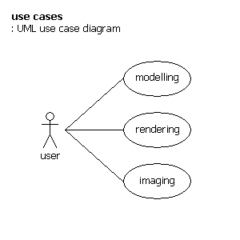

Agile
Able to move quickly and easily.
The Agile movement proposes alternatives to traditional project management.
Agile approaches are typically used in software development to help businesses respond to Unpredictability.

ASIIC (American Standard Code for Information Inter Change)
7 bits i.e. ASCII includes definitions for 128 characters.

UTF (Unicode Transformation Format) 8, 16, 18bits.

Integer literals (3 ways are there.)
Decimal (Base 10)
Octal (base 8)
Hexadecimal (base 16)

Octal Literals
0-7
Place a zero in front of a number
int six = 06
int seven = 07
int eight = 10
int nine = 11

Hexadecimal Literals:
0-9 A – F
Capital or small litters
Place Ox before the number or the option suffix.

Ex: For long values
Long lo = 1105L
Long so = 0xfffl

Floating-Point Literals:-
Represented by 64bits
Add a suffix ‘f’ to the floating-point literals.

Double literals
double d = 11.12D
double dd = 192.00d

Boolean Literal
True or false
Character literal
Char a = ‘a’
Char b = ‘c’
We can use Unicode values for character. “\u04E”
char c = -29 --- loss of precision.
char c = (char) -98

We can use escape code
char c = “\n”;
char c = “\t”;

Variables are just used for storing information
byte b = 27; legal
b= a+c; illegal
b= (byte) a+c;

Local variables are sometimes called stack, temporary, automatic, or method variables.

Default values:
Objects Reference ---------------------- null (not referencing any object)
byte, short, int, long -------------------- 0
float, double ------------------------0.0
boolean ------------------ false
char --------------------------- ‘\u000’

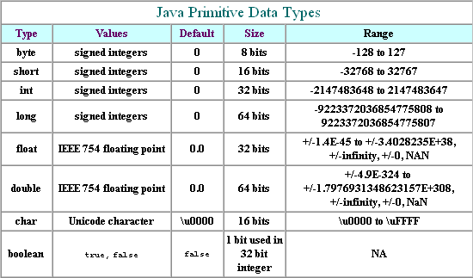

class
class is a blue print for Object
class is a template for an object that describes state and behaviour of an object.
this:
This always refers to object currently running.
Instantiation
The process of creating Objects from a class is called instantiation.

Object Creation
- Variable declaration that stores objects reference, [in stack]
- Creating an object involves using new operator in conjunction with a call to constructor to create an instance of the class.
Stack s= new Stack ();
Object References:
A ref provides a handles to an object that is created and stored in memory.

State:
Variables declared with in the class are called state of an object
Behaviour:
Methods are known as behaviour

Static member:
It belongs to class not to particular object
static variable, static method together know as static members
static: Only one copy of static member regardless of a number of instances of that class.
static method can’t be overridden.

static method in a class can always use a reference of the class’s type to access its members, regardless of whether these members are static or not.

Construction an array
Array:
int [] Key.
Key the reference to an int array Object.
It never legal to include the size of the array in your declaration.
Array declaration
<element-data-type> [] <array-name>;
int [] abc;
Array Construction
<array-name> = new <element-data-type> [<array-size>]
Array Declaration and Array Construction
<element-data-type>[] <array-name> = new <element-data-Type>[size];

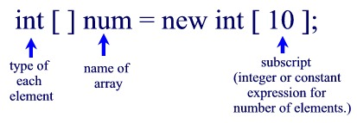

Multi Dimensional Arrays
int [][] array = new int [3] [];
array[0] = new int[2];
array[0][0] = 6

Initialization an array
1) <element-type> [] <array-name> = {<array initialise>}
int[] abc = {1, 2, 3};

2) Object array is declared as an array of objects class
Object [] objArray = {new Pizza (), new Dizza(), new Dizza(), null}

Anonymous Arrays: -
Java has another array creation combining from creation and initialized.
new int[] {3, 4, 5}
int[] array = new int [] {1, 2, 3}

static members are always accessible in a non static context.
non static member are not accessible in a static context.

We can use non static values in static context.

Packages:
A package is an encapsulation mechanism that can be used to
group related classes interfaces and subclasses.

Abstraction
Abstraction is a way of converting real world objects in terms of class. For example creating a class vehicle and injecting properties into it.
Encapsulation
The encapsulation is achieved by combining the methods and attributes into a class.
Inheritance
Inheritance is the property which allows a child class to inherit some properties from its parent class. (IS – A)
Polymorphism
The ability of super class reference to denote objects of its own class and subclass at runtime is called Polymorphism
Gives flexibility in extensibility.

Association
Association is relation between two separate classes which establishes through their objects.
Association can be
one-to-one,
one-to-many,
many-to-one,
many-to-many.

Aggregation and Composition are the two forms of association.

public class MyMainClass {
public void init(){
new otherClass.init();
}
}

Aggregation ( Has – a )
Aggregation has a relation ship between two classes. In this relationship the object of one class is a member of the other class.

Aggregation always insists for a direction.
public class MyMainClass {
OtherClass otherclass = new OtherClass();
}

Composition
Composition is a special type of aggregation relationship with a difference that it’s the compulsion for the otherClass objects to exist for
the existence of MyMainclass.

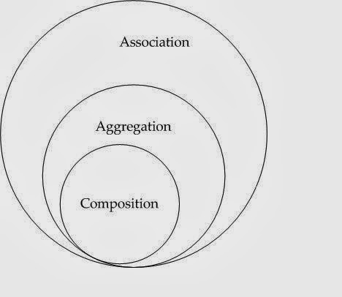

Abstract Method
Method prototype is declared.

Inheritance:
IS –A
Called super class sub class relation.
This means that an object of a subclass can be used where ever super class object can be used.

Aggregation
Define a relation Has – a
Has – a
Whose part relation ship tell how much subclass can use super class.
I.e. an object should not contain other object it contain only reference of that another object.

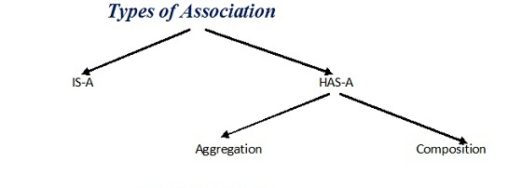

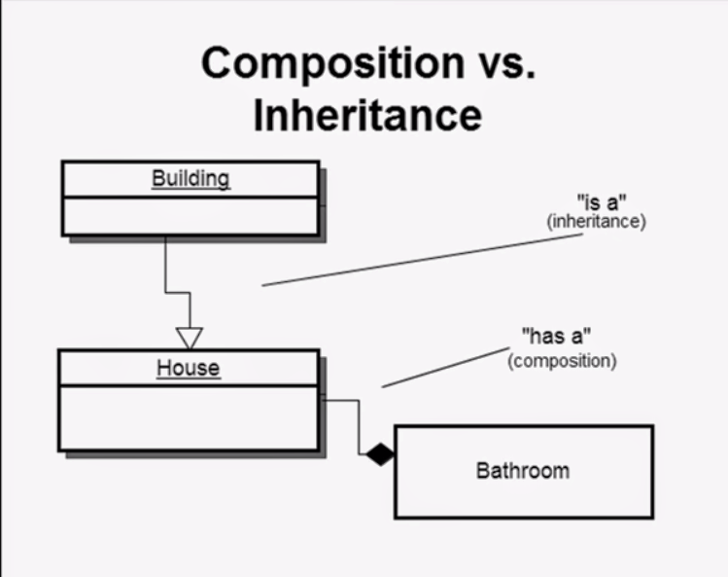

Polymorphism
The ability of super class reference to denote objects of its own class and subclass at runtime is called Polymorphism.
Gives flexibility in extensibility

Final
A primitive data type defined as final can’t be changed.
A class whose definition is complete can be defined final.
A final variable reference type can’t change its reference
value once it has been initialized, but the state of the object
it denotes can still be changed.

Modifiers: Modifiers fall into two categories.
Access Modifier (public, protected, noModifier/package , private)
Non Access Modifier (static, final, abstract, synchronised, native, transient, volatile.)

Default Access: Package level access.

Down Casting (converting a parent class reference back into a child class reference)
Casting super class reference to subclass is called down casting

if (objRef instanceOf String){
String ref = (String) objRef;
}

Upcasting (Converting a Child class object into a parent class reference)
Object obj = strRef;
superClassRef = subClassRef;

class Animal {
void sound() { System.out.println( “ Animal makes a sound !”);}
}
class Dog {
void bark(){ System.out.println(“ Dog barks….”);}
}

Class Main{
public static void main(String args[]){
Animal a = new Dog();
a.sound(); //works

a.bark(); // Not allowed (reference type is Animal)
Dog d = (Dog) a;
a.bark() // works

}
}

  - Upcasting: Treating a Dog as an Animal → general view
  - Downcasting: Treating an Animal as a Dog → specific view (only valid if it really is a Dog)

Garbage collection
If obj has any reference then it will be reachable.
Reachable reference: Any ref that makes an object reachable is called a reachable reference.
Object life time
Is lifetime of an object, when it is create to the time it is garbage collected.
JVM will typically run the garbage collector when it senses that the memory running low.
When java program makes a request for garbage collection the JVM usually grant the request in short order. But there is no guarantee.
System.gc () to call garbage collector
System.runFinlization() *Deprecated.
à to suggest that run pending finalize() methods.
static Runtime getRunTtime()
return Runtime obj associated with the current application.

Finalize * deprecated
Finalize method provides a chance to an object to undertake any action before its storage is reclaimed. Automatic garbage collector calls a finalize method in an obj that is eligible for garbage collection.

protected void finalize () throws Throwable.

finalize() method can be overridden

protected void finalize () throws Throwable {
itemValue = null;
super.finilize();
}

finalize can like any other method catch and throw exceptions.

class Abc {
protected void finalize () throw Throwable {
try{
if(objRef != null) {
objRef.close();
}
}finally() {
super.finalize();
}
}

finalize() methods are called only once.

Shallow copying
Copying primitive values and reference value while cloning is called shallow copying.
Shallow copy is a bit-wise copy of an object. A new object is created that has an exact copy of the values in the original object. If any of the fields of the object are references to other objects, just the reference addresses are copied i.e., only the memory address is copied.
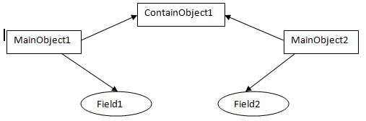

Deep Copying:
Cloning a composite object recursively is called deep copying.
A deep copy copies all fields, and makes copies of dynamically allocated memory pointed to by the fields. A deep copy occurs when an object is copied along with the objects to which it refers.

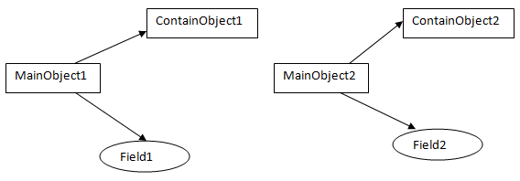

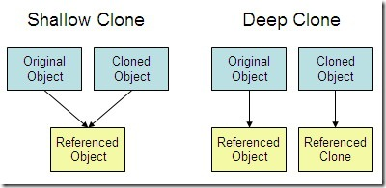

Object class
1) int hashCode();
To get a hash value of an object.

2) final class getClass()
return runtime of the object

3) equals (object)
return true if both objects are equal.
4) Object clone ()
New object that exactly same as the current object is created.

5) String toString ()
If sub class does not override this method it returns textual representation of the object which has the following format.
<name of class>@<hascode value of obj>
Abc.class@axe
5) protected void finalize() throws Throwable.
6) final void wait() throws InterruptedException
7) final void notify()
8) final void nofityAll()

String
String Objects are immutable.
In java each character in a string is a 16 bit Unicode character.
Unicode characters are 16 bit rich international set of characters is easily represented in Unicode Characters.

String constructor:
String (); is equals to “”;
String s1 = “You can’t change me”;
String s2 = new String (“You can’t change me”);
s1 == s2 à FALSE;
They are not referring to same
‘==’ operator will check for reference for objects.
s1.equal (s2) à TRUE
Equals compare two objects are equals

s = s.concat(“MORESTUFF”);
It Crete a new String Object, and give value MORESTUFF, and made‘s’ refer to it.

String x= “java”;
x.concat(“Rules”);
System.out.println(“x = ” + x);
String s1 = “Spring”;
String s2 = s1 + “summer”
s1.concat(s1);
s1+=”writer”;
System.out.println(s1 + “ “ + s2);
O/p spring writer spring summer

String Constant Pool:
JVM sets aside a special area of memory called String constant Pool. When compiler encounters a String literal it will check if the String is available in pool or not.
If available it makes new reference to it, other wise it will create String object i.e. String objects are immutable, for a single string Object may be multiple references, and if one reference is changes the String objects remain referees bad results.

Differences:
String s = “abc”;
1) Create one string object and one reference variable.
String s1 = new String (“abc”);
2) Create two Objects and one reference variable.
3) Here we use new so JVM create a memory outside of pool. And places one String Object in pool and one object outside of the pool.
Reference is goes to outside of the pool.

Methods:
charAt()
Return the character located at specified index.
concat()
Appends String to the end.
‘+’ also works.
equalsIgnoreCase()
Determines equalities of two Strings, ignore cases.
length()
Returns length of the String.
replace()
Replaces the occurrence of Char with new one
substring ()
Return a part of String.
toLowerCase()
Return String with lower case char.

toString()
return the value of a String
toUpperCase()
return a String with updercase char
trim()
removes white space from the end of a String.

StringBuffer
To make lot of changes to a String of character.
reverse() method available in StringBuffer class
Thread safe
Methods are synchronised
Works slow

StringBuilder
Is not Thread safe
Methods are not synchronised
Works faster

String x = “abc”;
x.concat(“def”);
System.out.println(“x= ” + x);
Output abc
StringBuffer sb = new StringBuffer(“abc”);
sb.append(“def”);
System.out.println(sb); h
Output abcdef

public synchronised StringBuffer append(String s)
Update the value of the object that invoked the method weather or not the return is assigned to a variable.

public StringBuilder delete(int start, int end)
public StringBuilder insert(int offset, String s)
StringBuilder sb= new StringBuilder(“123456789”)
sb.insert(4,”XYA”);
System.out.println(sb);

public synchronised StringBuffer reverse();
final String {
}
final StringBuffer {
}
String str = “you cannot change me”;

Final:
When we use
When all methods in class ever be overridden
When we dependent on the implementation of certain method.

Disadvantage
Class can’t be improved or specialised by another programmer.

Interfaces
1) All variables defined in an interface must be <public> <static> <final>
2) Interface methods must not <static> and they can’t be marked <final>, <strictfp> or<native>
3) An interface can extend many numbers of interfaces.
4) Interface constants are <public>, <static> and < final>.

- public Member:
Members marked as public can be accessed by any class.
- protected Member:
Same package + sub class in different packages, regardless of
- package.
No Modifier: within package.
- private Member:
Member’s marked private can’t be access by code in any class other than the class in with the private members declared.

Declaring a reference variable
Object o
String s1, s2, s3
Local Variables
Final is the only modifier available to local variables.
Local variable do not get default values so they have to initialize before use.

Object oriented aspects of java

IS-A tell Inheritance (i.e. extends and implements) (Building is a home)
HAS-A B.
A has a reference to an instance of class B (Home has a bathroom)

Why multilevel Inheritance: Not supported.
When class extends two class and both has same methods, then the compiler does not know which method to be called, this is called “Deadly Diamond of Death”.

Fig1

Overriding:
Advantage:
Ability to define behaviour that’s specific to a particular subclass type

Rules
- The access level can’t be more restrictive
- The overriding method can throw any uncheck (runtime) exception; regardless of whether the overridden method declares the exception.
- The overriding method must not throw checked exceptions that are new or broader than those declared by the overridden method.
- The overriding method can throw narrower or fewer exceptions. Just because an overridden method ‘taken risk’ doesn’t mean that the overriding subclass exception takes the same risk. Bottom line an overriding method doesn’t have to declare any exceptions that it will never throw regardless of what the over ridden method decides.
- A method can’t be overridden if it declared final, static, private.

- Must have same return type, except as of java 5, and then return type can be a subclass this is known as covariant return.
- Compile time polymorphism is method overloading.
- Runtime polymorphism is method overriding.

Invoking Super class Version of an Overridden method
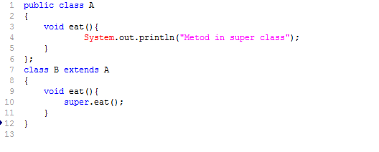
Overloaded Methods:
Overloaded methods let us reuse the same method name in a class but with different arguments (and optionally, a different return type)
- The overloaded method must change the argument list
- Can change return type
- Can change access modifier
- Can declare new or broader checked Exceptions.
- A method can be overloaded in same class or in subclass.
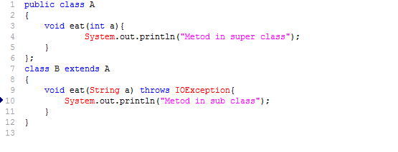

Method return types
- We can return null in a method with an object reference return type.
- An array is a perfectly legal return type.
- In a method with an object reference return type you can return any object type that can be implicitly to the declared return type.

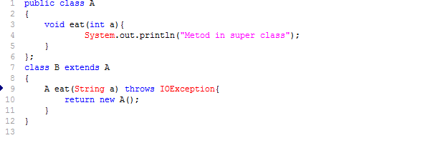

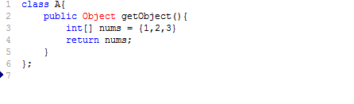

Constructors and Instantiation:
- With out Constructor we can’t create objects
- We can’t make a new object without invoking not just the constructor of the objects actual class type, but also the constructor of each of its super class.
- Constructor are run when we use <new>
- Abstract class also has constructors – But no
- Constructors are used to initialize instance
- e variable state
- Constructors can be overloaded.

Constructor Chaining:
Horse h = new Horse ();
- Horse Constructor is invoked, every constructor invokes the constructor of its super class with an (implicit) call to super (), unless the constructor invokes an overloaded constructor of the same class.
- Animal constructor calls the object class Constructor, at this point we are top of the stack.
- Object variable are given their explicit values
- Object constructor Completes
- Animal instance variable are given explicit value
- Animal Constructor completes
- Horse instance variable given their explicit value
- Constructor completes
4) Object ()
3) Animal () call super()
2) Horse () call super().
1) main () class new Horse();

Rules for Constructors
- Constructors can use any access modifier including private. (private we mean only code with in the class wants to allow an instance of the class to be used the class must provide a static method or variable that allows access to an instance created from with the class.
- A Constructor and a Method can have same name
- If a variable and a class have same name then we say it as Shadowing.
- Every class has it’s first statement, ether a call to an overloaded constructor (this ()) or a call to super Class Constructor.
- If we do a constructor and you do not type in the call to super () or a call to this (). The compiler will insert a no argument call to super () for as the very first statement in the constructor.
- A no argument constructor is not necessarily the default constructor (i.e. compiler supplied)
- Only static variable and methods can be accessed as part of the call to super () Example super (Animal. NAME) is ok.
- An abstract class have a constructor and those constructors are always called when a constructor subclass is instantiated.
- Interfaces do not have constructors. Interfaces not part of an objects inheritance tree.

Default Constructor
- The default constructor has the same access modifier as the class
- The default constructors has no arguments
- The default constructor include a no arg call to the super constructor(Super())

1) class Foo{ }

Compiler generated Constructor code
class Foo {
Foo() {
Super();
}
}

2) Class Foo{
Foo(){}
}

Compiler generated Constructor code
Class Foo{
Foo(){super()}
}

Class Animal {
Animal (String name) {}
}
Class Horse extends Animal {
Horse () {super () ;}
}

The above code won’t work
If super constructor has arguments you must type in the call to super (), supplying the appropriate arguments.
If super class does not have a no argument constructor you must type a constructor in sub class.
Ex
class Foo{
Foo(String s) {
super();
}
}
Complier generated constructor
Compiler will do nothing to insert anything.
class code
class Foo {
Foo(String s) {}
}

Complier generated constructor
class Foo {
Foo(String s) {
Super();
}
}

- The first line of constructor must be a call to super() or a call to this()
- It call default constructor, we can parameter super() or a call to this(parameter)
- But both should not be in the constructor
- Each of those calls must be the first statement in a constructor.
- Compiler won’t put a default constructor if one or more constructor is there.

Good Programming practice tight Encapsulation lose Coupling and high Cohesion in a class.

Coupling (Loose coupling is good practice)
Coupling is the degree to which one class knows about another class.

Cohesion (High cohesion is good Practice)
Is used to indicate the degree to which a class has a single, well focused purpose
Intra-dependability within elements of a module.
Higher cohesion is a good thing.

2 Mints Drill
Encapsulation helps hide implementation behind interface.
Have two features
- Instance variables protected
- Using setter and getter methods provide access to instance variables
Method can be OverLoaded/OverRidden.
Constructors can be Overloaded but not Overridden.

Stack and Heap
- Instance variables and objects live on the heap.
- Local variables live on the stack.

Test t = new Test();
Stack Heap
t --------------------> Test object (x=10)

_____________________________________________________________________

Primitive literal is merely a source code representation of primitive data types.

Wrappers
- To provide a mechanism to wrap primitive values in an object so that
the primitives can include in activities reserved for objects like collection method return type.
- To provide assortment of utility functions for primitives. Most of these functions are related to various conversions. Converting primitives to and from String Objects and converting primitives and String Objects to and from different base. Such as Binary, Octal, Hexa decimal.

Privmitie wrapper class Constructor Arguments
boolean Boolean boolean or String
byte Byte byte or String
char Character char
double Double double or String
float Float float or String
int Integer int or String
long Long long or String
Short Short short or String

Wrapper Constructor
Integer i1 = new Integer(42);
Float f1 = new Float(3.14);
Character c1 = new Character(‘c’);
Boolean b1 = new Boolean(“false”);

valueOf ()
to create an wrapper Object
valueOf() has two forms
- valueOf(‘String’, radix)
- valueOf(‘String’)
Ex:
Integer i1 = Integer.valueOf(‘10101’, 2);
Float f = Float.valueOf(‘3.123’);

XXXValue():-
To convert wrapper numeric to primitive
No arg method.
Integer i2 = new Integer(42);
byte b = i2.byteValue();
short s = i2.shortValue();

ParseXXX() :
- return the named primitive by taking string argument
  - int I = Integer.parseInt(“123”);

parseXXX() valueOf()
--------------------------------------------------------------------------------------
1 Take String as arguments 1) take string argument
2 return primitive 2) return Wrapper
3 two constructors 3) two constructors

toString ()
It allows us to get some meaning full representation of given object.
Used in collections when fetching diff types of obj we use to get some
sort of meaning full rep.
toString() method is overloaded.

- toString()
- toString(String)
- toString(String, int)

toXXXString() (Binary, Hexadecimal, Octal)
The lnteger and Long Wrapper Class let us convert numbers in base10 to other bases. These conversion methods toXXXString() taken an int or long and return a String representation of the converted numbers for example.

String s3 = Integer.toHexString(245);

Equals ()
Method tells two instances of a given class are meaning full equivalent or not.
The definition is subjective to internally, for wrapper class two objects are equal if they are same type and have same value. When we need to know if the objects themselves are equals method.

==
Two instances of the following wrapper objects will always be == when their primitive value are the same. When we really need to know if two references are identical use ==
To determine if two reference variables refers to the same object.

- Boolean
- Byte
- Character from /u0000 to /u007 (0 - 127)
- Short and Integer from (-128 to 127).

Integer i1 = 1000;
Integer i2 = 1000;
If(i1 == i2)
S.o.p (“Diff Object”);

Integer i3 = 10;
Integer i4 = 10;
I3 == i4;

Overriding hashCode()
hashCode are typically used to increase the performance of large collection.
Hashcode value of an object is used by some collection classes.
Hashcode is an object ID it is not necessarily unique.
<classname>.<valueofobject>
HashMap, HashSet use the hashcode value of an object to determine how the object should be stored in the collection.

Exception Hierarchy
Fig

Object

Throwable

Error Exception

RuntimeException
1) Null pointer exception
2) ArithmaticException
3) ClassCastException
4) IndexOutOfBoundsException
1) ArrayIndexOutofBoundsException
2) StringIndexOutofBoundsException

CompiletimeException
1)ClassNotFoundException
2) NoSuchMethodException
3) NoSuchFiled Exception
4) InterruptedException

Java.lang
¬
Exception
¬
IOException
EOFException
FileNotFountException

Error
AssertionError
LinkageError
ThreadDeath
VirtualMachine Error

Other subclass of the Exception class defines other Categories of
exception, Example IO related exception (IOException, FileNotFound
Exception, EOFException) and GUI Exception (AWTException)

There are two subclass derived from Throwable, Exception and Error
class. Error represent unusual situation that are not caused by
program error.
JVMException: Those exceptions or errors that are either exclusively or
most logically thrown by the JVM.
Programmatic Exception: Exception throws by Program API’s

Working Dates, Numbers and Currencies
java.util.Date: Is obj used for date.
java.util.Calendar: Helps us to convert and manipulate date and times.
Java.text.NumberFormat: This class is used to format numbers and currencies for local around the world.
Java.util.Locale: This class is used in conjuction with DateFormat and NumberFormat to format dates, numbers and currency for specific locals
Calander cal = Calander.getInstance();
DateFormat (abstract class)
DateFormat.getInstance();

Java 1.5 features

Static import
Auto boxing and auto Un boxing
Enumeration
var args
Enhanced for loop
String Builder
Generics

Static import
When we use static import we directly call static member by there name without fully qualifying names.

AutoBoxing and AutoUnBoxing
Makes us more convenient to use wrapper classes.

Enumeration
Allows a variable have predefined values
Var – args:
Methods with variable argument list.

Enhanced for loop.
for (String s : String[]){
}
StringBuilder.
Non synchronized
Generics
Mean parameterized types.

Auto Boxing
Boxing and unBoxing make using wrapper classes more convenient.

Ex :
In java 4.0
Integer i = new Integer (789);
Int j = i.intValue ();
J++;
i = new Integer (j);
In JAVA 5.0
Integer i = new Integer (789);
i++;
S.o.p(“y=”+i);
In java 4 we are saying Wrapper Objects are immutable, in java 5 Wrapper can be directly be used.

Integer i1 = 10 //Auto boxing
int i = i1 //Autounboxing

Autoboxing is process by which a primitive type is automatically
encapsulated into its equivalent type wrapper. When ever an object
of that type is needed.
Autoboxing -à valueOf ()
Autounboxing à int value ()

static import
When using static import it is possible to refer to static members directly by their names with out having to qualify them with the name of their class.

import static package.*;
Ex:
import static demo.demo1.meth;
demo à package name
demo1 à class name
metho à static method name.

Var – args:-
Method with variable argument List (args)
In JDK 5.0 allows creating methods that can take a variable number of arguments

Arguments:**
The things, we specify when method are invoked.

Parameter: Actual method declaration.**

Var-arg Type:
When you declares a var-arg Parameters you much specify the type of the arguments this parameter of your method can receive.

Basic Syntax:
To declare a method using a var-arg parameter you follow the type with an elipse(…), a space and then the name of the array that will hold the parameters received.
other parameters: It is legal to have other parameter in a method uses a var-arg.

Var-arg Limits
The var-arg must be the last parameter.

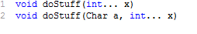

Declaring Enums:
Allows a variable have a predefined value.
Enums help to reduce the bugs in your code.

enum CoffeSize {BIG, HUGE, OVERWHELMING}

//To get value from enum is
CoffeSize cs = CoffeSize.BIG

Enums can be declared as their own separate class or as class members.

Enum CoffeSize {BIG, HUGE, OVERWHELING}

class Coffe {
CoffeSize size;
}

public class CoffeTest1 {
public static void main (String args []) {
Coffe drink = new Coffee ();
drink.size = CoffeSize.BIG;
}
};

Enum can be declared public or no modifiers.

Enum in a class

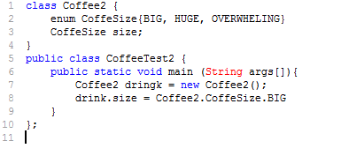

Enum should not be declared inside a method.

Collection Frame work.
CollectionFrame work integrated in 1.2 and expanded in 1.4 and again in 1.5.
<interface>
Queue
LinkedList PriorityQueue

Collection: - represents the data structure in which objects are stored.
Collection : ---- Interface
Collections: - A class that holds static collection utility method.

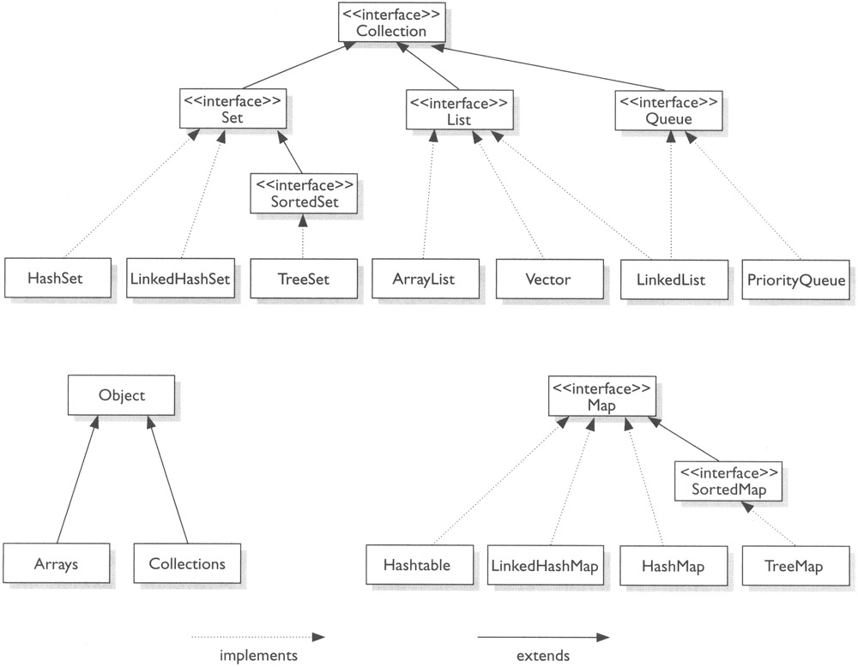

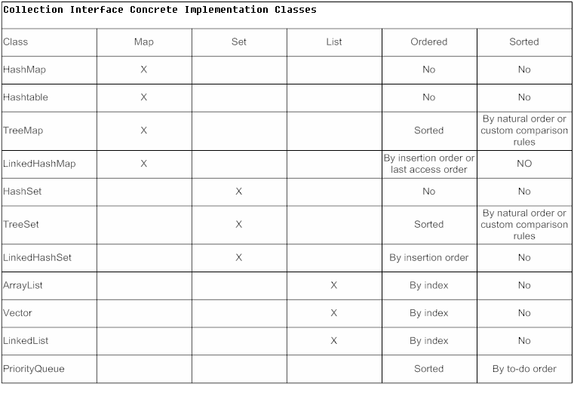

Comparator (java.util.comparator) Interface
- Based on total order
- Precise control of ordering is achieved by creating a customized comparator
that imposes a specific total order on the elements.
int compare (Object o1, Object o2)

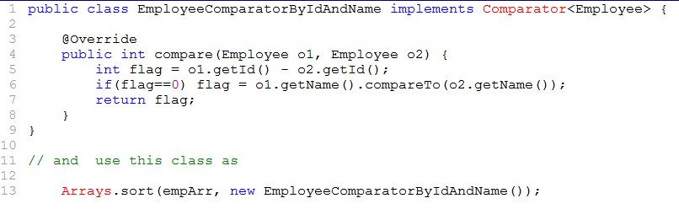

Comparable (java.lang.Comparable) - interface
- A class can define the natural order of its instance by implementing the comparable interface.
int compareTo(Object o) ClassCastException
- The natural order for objects of a numeric wrapper type is ascending order of
the value of corresponding numeric primitive type.

Working with collection
Decorators: A Decorator object wraps around a collection, modify the
behaviour of the collection.

Synchronized Collection Decorators
static Collection synchronisedCollection(Collection c)
static List synchronisedList(List list)

Sort Collection
Contain only one element or one entity
By using static factory method.
static Set singleton (Object o)

Collection Interface
Basic Operations
Int size();
boolean isEmpty();
boolean contains(Object element);
boolean add(Object element);
boolean remove(Object element);

Bulk Operations
boolean containAll(Collection c)
boolean add All(Collection c)
boolean remove All(Collection c)
boolean retain All(Collection c)
boolean clear ()

Fig
Table
Array Operations
These operations convert collection to arrays.
Object[] toArray();
Object[] toArray(Object a[])

Iterator (Interaface)
Allows us sequential access to the element of a Collection.
Iterator iterator ()
return an object which implements the Iterator interface

boolean hasNext()
return true if the underlying collection still has elements, left return
the current element.

Object next ()
Moves the iterator to the next element and return the current element
Object remove ()
removes the element that return by the next () method.

Lists
List is Collection that maintains their elements in insertion order.
Element in list are ordered.
A zero based index can be used to access the element at the position
designed by the Index value.
Allows duplicate elements.

Object get (int index)
Return element at the specified index

Sets
- Do not allow duplicate elements.
- Set can contain at most one null value.
- HashSet, Linked HashSet and TreeSet
- To fetch values we use iterator()

ArrayList, LinkedList and Vector:
Vector and ArrayList are implemented by dynamically resizable array, provides fast random access and fast list traversal.

ArrayList
- Non synchronised
- Not Thread safe
- Performance good

Vector
- Synchronised
- Thread safe
- Performance is low

Linked List
Implemented by double linked list.
- Insertion and deletion in D.L.L are very efficient.
Some more method are added to L.L is

void addFirst(Object obj)
void addLast(Object obj)
void getFirst();
void getLast();
Object removeFirst()
Object removeLast();

Maps
A Map defines a mapping from key to values.
A map does not allow duplicate keys.
Key is unique.
Key is mapped to one element at most.
Many-to-One relation to key values.
Key and value must be object.

Basic Operations.
Object put (Object key, Object value)
Will insert key, value into the map
Object get (Object key)
Return the value to which the specified key mapped or null
Object remove (Object ob)
boolean containKey(key)
int size();
boolean isEmpty();

Bulk Operations
Object putAll(Map m)
void clear ();

Collection View
Set keySet()
Collection values();
Set entrySet();

Iterator<Entry<Integer, String> > new_Iterator = intType.entrySet().iterator();
charType.forEach( (key, value) -> System.out.println(key + " = " + value));

These methods are reflected in view and vice versa.
Changes in view are reflected in view and vice versa.
These methods return a set view of keys.
A Collection of values, and Set view of <key value> entries
Each <key, value> in the entry set view is represented by an
object implementing the nested Map.Entry interface.
Interface Entry {
Object getKey()
Object getValue()
Object setVavlue(Obj val)
}

fig
Entry
Is nested class of map
It represents an entry view in a set

HashMap, LinkedHashMap and HashTable.

The class HashMap, HashTable implements unordered maps
Linked HashMap provided order maps
TreeMap implements sorted maps.

HashMap
Is not a thread safe
Null value allowed
Not a legacy classes

HashTable
Thread safe
Allow non null objects
Performance penalties
Legacy class

LinkedHashMap
Elements are in inserted order
Implemented by double LinkedList and HashTable.

Threads:
Creating a thread Using
java.lang.Thread (class)
java.lang.Runnable (interface)

Multitasking
Allows several activities to occur concurrently on the computer

Process based multitasking
This allows process (i.e programs to run) concurrently on the computer.
Ex: Running spread sheet while working with word processor.

Thread based multitasking
This allows parts of same program to run concurrently on the computer.
Adv:
1) Thread share same address space.
2) Context switching low.
3) Cost of communication low.

Java supports thread based multitasking and provide high
level facilities for multithreading program.

class can get a lock on java.lang.Class object associated with class
Given a class A, the reference A.class denotes this unique ClassObject.

Race condition
Leaving Object in inconsistence state by two or more threads.

- Synchronized block

Syntax: synchronized (<object reference expression>)

Ex:
public Object pp(){
Synchronized (this) {
}
}

- An inner object might need to synchronize on its associate outer
Object in order to ensure integrity of data

class Outer {
private double mypi;
protected class Inner {
private void setPi() {
synchronized(this) {
myPid= math.pi;
}
}
};
- synchronized blocks can also be specified on a class lock
synchronized (<class name>.class) {
<codeblock>
}
static void classAction(){
Synchronized (A.class) {
//code
}
}

Thread Transitions
Fig.
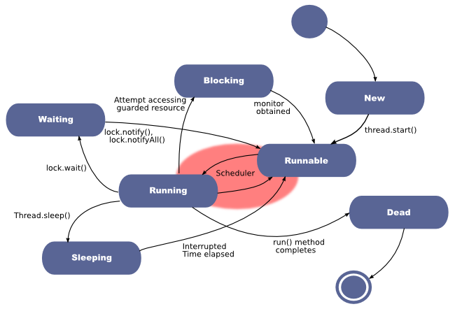

wait ()
When condition for its continued execution was not met
Fig :

join ()
When a thread invokes Interrupt () method of thread i.e
waiting for notification, waiting for join completion, then the thread
will throw a check exception i.e. Interrupt Exception.
Fig

notify() is used to unblock one waiting thread.
notifyAll () Is Used to unblock All Waiting Threads.

Inner class.

Introduced in JDK 1.1
- static member class and interfaces
- Non static member class (Instance inner class)
- Local classes (with in method or block)
- Anonymous class (Run time objected created without class name)
2, 3 and 4 are called inner class

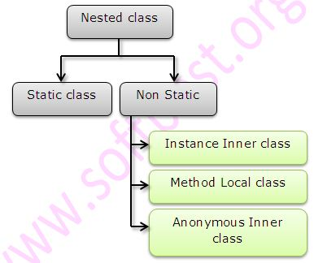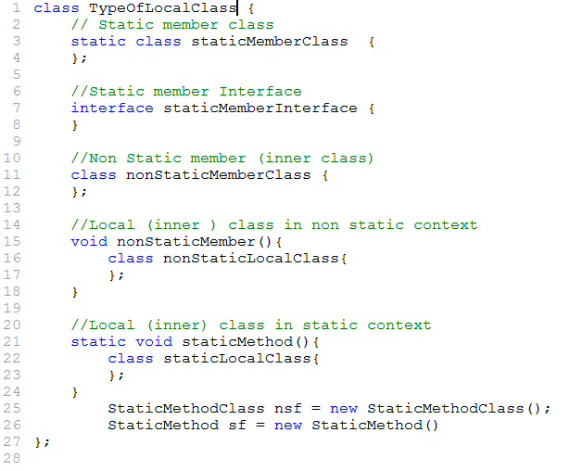
1) Static member class or Interface.
- Can be instantiated by using their full name.
- No enclosing instance is required to instantiate a static member class.
- It can be instantiated by its full name.

2) Non Static member class.
- Class are defined as instance members of other class, just like fields and
Instance methods defined in a class.
- An instance of a non static member always has an enclosing instance
associated with it.

3) Local class
- Can be defined in the context of a block as in a method body or local block.

4) Anonymous classes
- Is an inner class, defined in an expression and instantiated on the fly.
Note (Interfaces)
- There are no non-static members, local or anonymous interface.

Static Member classes and interface
Static member classes and interfaces can only be nested with in other
static member or top level class.
A Static member class can be instantiated without any reference to any
instance of the enclosing context.

Accessing members in enclosing context
- Can access other members that are declared static within same
class.
Accessibility: Can have public, protected, package/default, private.

Non static member class:
- Instance of a non-static member class must be created in the context of an instance.
- Final, static variables allowed.
- No static class can access its enclosing class members
including private members
- Non-static class can have any accessibility public,
protected ,package/default, and private.

class A {
class B // non static {
final static int x =10;
};
};

class C {
public static void main(String args[]) {
A a = new A ();
B b = a.new B ();
}
};
<Enclosing Object ref>.new <non-static member class constructor call>
class A {
int i = 10;
class B { // non static
int k = A.this.i;
};
};

Local Classes:
A Local class that is defined within a block.
This could be a method body, a constructor local block, a static
Initialize or an instance initialize.

Block in non-static context
Non static local class:
Have the same capability as a non-static member class.
“this” reference is available.
Static block
Implicit static in sense, no instantiation required.
This is a static member class
Here there is no need of static key word

**Some restriction that apply to local classes
Local class can’t have static member, however final static fields are allowed.
Local classes can’t have any accessibility modifier.
A local class can access final local variables, block parameter in the scope of context.
“this” is applicable static, not static Local classes.

Accessing members in the Enclosing class
A Local class can access members inherited form its super class in the usual way. It for static and no static references.

class A {
int a;
};

class B {
final int c;
void M1(){
int m1;
class c{
//static members not allowed
//only final allowed.
};
}
};

Anonymous classes
Class are usually defined first and instantiate next using new operator
Anonymous class combines the process of definition and instantiation into a Single step.
Defined in an expression that evaluated to a reference denoting an object.
Objects are created on the fly.
Local class’s anonymous class can be defined in static or non-static context, the key word static never used.
Anonymous class can’t be define constructor

Syntax:
new <Super-class> (Optional argument list)
{<Member declarations>}

Optional arguments are specified these are passed to super non static members and final static field are allowed in the class Body.

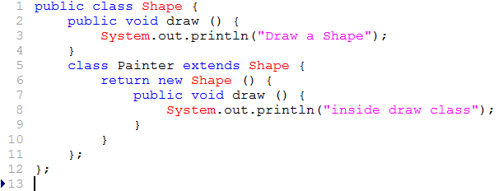

Constructors can’t be inherited i.e. we are not override constructors.

Yes an Exception can be re thrown.
Example
Try {
} catch(Exception e){
Throw e;
}

Yes a lock can be acquired on a class i.e. class’s class object.

public class DemoClass
{
public void demoMethod(){
synchronized (DemoClass.class)
{
//other thread safe code
}
}
}

Wrapper classes are class allow primitive type to be accessed as object.

Externalizable :
We have a complete control over class’s serialization process.
readExternal()
writerExternal()
Thread enters a dead state when it terminates.

Thread enters ready state when it is in interrupted while it is sleeping.

Use of inheritance:
Using interface we can implement multiple inheritance.

Start() method is used of Thread class is invoked to cause an object to begin executing as a separate thread.

What is ResourceBundle Class?
The Resource Bundle class is used to store Local specific resources that can be loaded by a program for program appearance to a particular Locale.

System class
Used for system resources.
Runtime System class
To access Runtime System.
To access Runtime resources.

null is a key word.

instanceof operator :
Left operand is an Object reference or null value and the right operand is a class reference or array type.

Objref or null instanceOf classref or arrayRef

Level of thread state is
ready à running à wait à dead

Difference between file and Random access file.

File represent file class encapsulate the files and directories of the local file system.

Random access file class provides the methods need to directly access data contained in any part of a file.

Java.util.EventObject
Java.util.EventListener

Default value of String is null
‘= ‘is right associative.

Singleton class
Singleton class whose only one object can be created at a time.
By providing Constructor private and providing static methods that return its instances.

Deserilazation :
Is a process of getting an object.

Every class contains 4 Method.
public string toString();
public string clone()
public string equals()
public string hashCode()

An object’s finialze() method may only be invoked once by the garbage collector.

Marker Interface
- Remote (java.rmi.Remote)
- SingleThread
- Serilizable
- Clonable
- EventListener

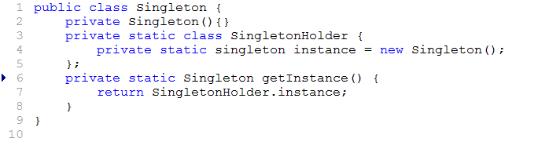

Lazy loading
Initialization on demand

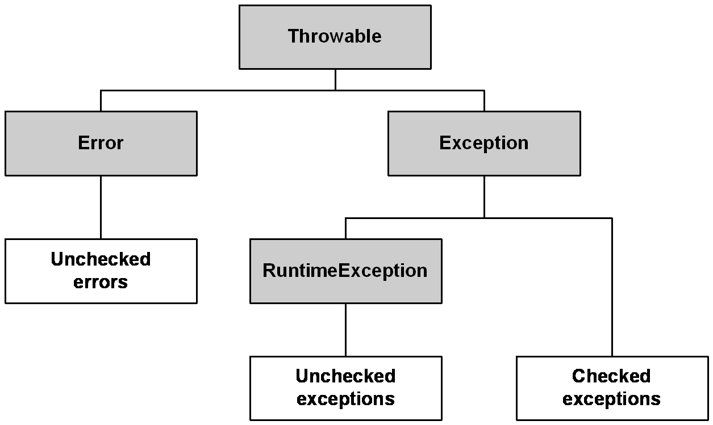
throw
to throw an exception explicitly
syntax throw ThrowableInstance();

throws
If a method is capable of causing an exception that it doe not handle it must specify this behaviour so that caller of the method can guard themselves against that exception.

Why java doesn’t support multiple inheritance.
Because to avoid ambiguity with in the class.
Marker Interfaces
1) Java.rim.Reomte
2) javax.servlet.SingleThreadMode.
3) Serilizable
4) Clonable
5) Event Listener

Dictionary
Dictionary is an abstract class based on key value pairs, keys are unique. Since we get the value through a key.
Key and Values are Objects.
Properties: -
Is a subclass HashTable where Key Value pairs are String.

Serialization : The process of saving object state to a file system.

The process of converting an object from java supported form to file supported form or network supported form.

Deserialization : The process of reading state of an object from a file.

The process of converting file/network supporting form to java supporting form.

Implementation :

Using two stream, we can implement serilization
1) fileOutputStream
2) ObjectOutputStream

Using two stream, we can implement deserilization
1) FileInputStream
2) ObjectInputStream.

Dog d1 = new Dog();

FileOutputStream fos = new FileOutputStream(“abc.ser”);

ObjectOutPutStream obj = new ObjectOutPutStream(fos);

obj.writeObject(d1);

FileInputStream fis = new FileInputStream(“abc.ser”);
ObjectInputStream ois = new ObjectInputStream(fis);
Dog g = ois.readObject();

-> Object should implement Serilizable interface.
-> if object is not implementing Serilizable interface and trying to serilize then we will get
NotSerializableException.

Transient variables do not participate in serialization process.

Static VS transient
Static -> class level data.
Serialisation applicable to object.
Static variables is not part of object state. it won’t participate in serialization process.
Declaring static variable as transient , there is no use.

Final VS transient.

Final variables are replaced by values at compile time only.
Transient is no use on final variables.

Object Graph

When we serializing an object, the set of all objects which are reachable from that object will be serialized automatically.
This group of objects is nothing but object graph.
Declaration | O/P
int i = 10;  int j = 20 | 10,20
transient int i = 10;  int j = 20 | 0,20
transient static int i = 10;
transient int j = 20

int i = 10;
int j = 20

int i = 10;
int j = 20

Servlet versions
Servlet 3.1 (javaEE 7)
Non blocking I/O, HTTP protocol upgrade mechanism
Servlet 3.0 (javaEE 6, javaSE 6)
Plug ability, Easy of development, Async Servlet, Security,
File Uploading.
Servlet 2.5 ( java EE5, java SE 5)
Supports annotations.
Servlet 2.4 (J2EE 1.4, J2SE 1.3)
Web.xml uses XML Schema.
Servlet 2.3(J2SE 1.3 J2SE 1.2)
Addition of Filter.
Servlet 2.2 (j2ee 1.2 , j2se 1.2)
Become part of J2EE, Introduced independent web
Application in .war file.
Servlet 2.1 (unspecified)
First official specification, added RequestDispatchar, ServletContext

Servlet 2.0 (jdk 1.1)
Part of java Servlet Development kit 2.0
Servlet 1.0
JDBC
(Connection pooling)
JDBC is a standard java API for interacting with relation database from java application.

JDBC Provides programming interface which are used to interact with certain Object.

The interface implement class are provided by vendor, these class and interfaces are available in a ZIP file or JAR file.

Java.sql.* is the package where the database independent class and interfaces are located.

Driver Manager is the first class to be executed.

Driver Manager is provided with String called JDBCURL while requesting a Connection.

JDBC URL Consists of
Driver reorganization information.
Data base information.

Class.forName () : -
Allows us to explicitly load a class by its name, we have to provide fully qualified class name (with package name)
Ex: oracle.jdbc.driver.OricaleDriver

1) When loading into memory it registers itself with the java.sql.DriverManager class as an available database driver.

2) Next step is asking Driver Manager class to open a connection.
jdbc connection usually begins with
jdbc:subprotocol:subname
Ex: jdbc:oracle:thin@localhost:1521:aa

3) Statement object is never instanced directly, instead a program call the createStatement() method of Connection to obtain a Statement Object.
Statement stmt = con.createStatement();
Then execute the statement.

4) DriverManager uses URL String as an argument and the JDBC Management layer located and loads the appropriate driver for the target database to achieve the application is attempting to link.

For insert, delete, update we use executeUpdate (String) and return type is int.
For creation of new table execute () return Boolean.
For select statement executeQuery(String) return type ResultSet.

A JDBC application can be logically divided into two ways.
1) Driver Layer.
2) Application Layer.
The Driver Layer establishes the Connection and provider it to the application layer programmatically Connection Is represented as an Object which implemented the following interface.

Through Object act like a vehicle for sending sql command to the database.
DriverManager.getConnection(String)
.getConnection(String, Properties)
.getConnection(String, String, String)

Delete: Is Transitional i.e. can be rolled back.
Truncate: Will empty the common with auto commit but differ in the following ways.

Transaction:
Transaction is smallest unit of work (i.e. further divisible)
Transaction introduces reliability. Either all success or all fail.
Transaction has to be started and must end with either commit or rollback command.
Commit --- Makes the changes permanent.
Rollback – Discards the changes.
In JDBC Tx are implicit by default.
To make Tx manageable
conn.setAutoCommit (boolean)
true - implicit
false - manual
conn.setAutoCommit(boolean false)
conn.commit()
conn.rollback()

When we commit or rollback a new Transaction automatically begin this Tx. We scan till the next commit or Rollback.

String = rsmd.getColumnTypeName(int)
Return the database specific data type name for the Column

String = rsmd.getColumnClassName(int)
Return a java class name whose instance will be used in java to represent column data Object.

rsmd.isNullable(int) to delete whether column allowed null or not.

Result set Metadata.ColumnNoNull
.ColumnNullable
.ColumnNullableUnknow

Binary columns like text, images have to be read, has if we are reading from a stream.
InputStream is =rs.getBinaryStream(int)
InputStream is =rs.getBinaryStream( (String)

Detecting nulls in the database
Boolean = rs.wasNull();
Return true if the latest retrieved column has the null value in database.

Prepared Statement
If a statement is executed more than once. Then prepared statement preferred.

Callable Statement

Statement

Prepared Statement

Callable Statement
Callable Statements are used to invoke Stored Procedure and functions.

Stored Procedure is a means of putting the application logic in the database server itself instead of in the front end.

Advantage:
- Application performance would be increased due to number of trips made to the database server is less.
- Any Changes in application logic is at only one place compare to the need of distribution if such logic is in the front end.

Procedure procedure-name (param1, param2)
As
Code
End.
Param1 - @ param name type mode.

Every procedure parameter has name type end mode
- parameter name :
Is as per the syntax supported by the database.
- Parameter Type
Is as per the data type supported by the database
- Parameter Mode : Specified the direction of the parameter

Type Mode:
IN implies the parameter values has to be specified while invocation
OUT Parameter value will travel from server to client after procedure exception.
INOUT is bidirectional parameter i.e. we can provide a value while invoking and the parameter value will travel from server to client after invocation

CallableStatement cs = con.prepareCall(String);
(“{call get_salary(?,?)}”)

cs.registerOutParameter(3, Types.INTEGER);

Types of JDBC Drivers
Based on connectivity strategy JDBC Drivers are divided into four types.

Type1: jdbc driver (JDBC Driver)
Disadvantage
1) ODBC Driver is in native format the following possibilities can exits
- platform dependency
- Platform securities are under threat. Since native code doesn’t come under the security of JVM Security manager.

- ODBC Drivers for the concerned DB must be installed on the machine when ever we intend run the application

- We has to explicitly create an ODBC (DSN on the machines)

- Maintenance is required.

Type 2 partly java partly native
These drivers exposes DB Specific feature in a made simple way.
For example oracle provides OCI Oracle call level interface
OCI interface as there implementation will exists in a native Library.
Type2 JDBC Drivers and given by Oracle called as OCI ODBC Drivers.
All advantages associated with type1, approach will also come in type2. Except explicitly creating DSN.

Type3 Network Protocol JDBC Driver.
In this approach the driver communicates with an intermediate server which in turn provide.

Jdbc àseveràDB

This kind of driver should only be used in those circumstances where the applications don’t have a permission to directly communicate with DB.
When a applet want to communicate with DB it should use types drivers.

When loading into memory it registers itself with the java.sql.DataMaganger class as an available database driver.

Advantage 3 (Network protocol jdbc drivers)
- There is a single entry point to all the clients’ i.e. through the server. This server can use Connection which would definitely improve the performance.
- DB Server can maintain a cache this Connection reduces No of trips to DB there by improving the performance.
- Callback concept can be implemented in this approach.

‘.’ The notification given to the client when data changed in cache.

Type 4 JDBC Drivers
Pure java drivers
These drivers directly talk to the database without need of any native library or a requirement of intermediate server.
The Driver will establish a network connection and communication with the DB over the same protocol like TCP/IP

New feature in jdbc JDBC 2.1
From JDK1.2 on words the following feature where added
Even through application could compile when we use such feature, it will not run unless the chosen driver improves the feature
Batch update
Scrollable and updatable result set.

Batchupdate
The batch is a group of SQL Statements submitted together in one single trip. The database server executes the statement and returns the result of integer array.

Statement stmt = conn.createStatement();
Stmt.addBach(String1);
Stmt.addBach(String2)
int [] = stmt.executeBatch();
If statement execution fails the batch execution is stopped and following exception is raised.

Prepared Statement
1) We have to make number of trip number of SQL Statement.
2) Similar Statements are used.

Batch update
- Single trip is enough
- Different statements are closed.

Scrollable and updatable result set
By default Result set is forward direction only
Scrolling feature allows to more arbitrary row.
To change result set type the following statement object must be obtained in the following.
Statement stmt = con.createStatement (int type, int concurrency)

Type
1) ResultSet.TYPE_FORWARD_ONLY
2) ResultSet.TYPE_SCROLL_INSENSITIVE
3) ResultSet.TYPE_SCROLL _SENSITIVE

concurrency:
1. Resultset.CONCUR_READ_ONLY
2. Resultset.CONCUR_UPDATEABLE.

TYPE
ResultSet.TYPE_FORWARD_ONLY is always insensitive.

Scrolling feature
boolean rs.next();
rs.first();
rs.previous()
rs.last();
rs.absolute(int)
Take the row pointer to the particular row irrespective of current row positon.
rs.relative(int) , rs.relative(+int | -int)
The current position is taken into consideration.
void rs.beforeFirst()
void rs.afterLast();
int rs.getRows() Gives current row number.
int rs.findColumn (String) returns Coolum position in the result set.

ResultSet.TYPE_SCROLL_INSENSITIVE
Is like a snap shot it gives us data which is present in the database during query execution. Latest changes will not visible to the result set.
The changes to the result set are visible
A sensitive result set doesn’t have data rather it has pointers which uniquely identify a row in the database.
Disadvantage
With ResultSet.TYPE_SCROWL_INSENSITIVE

Prefer Sensitive resultSet
1. Multiple users are operating the same database.
2. Want of latest data.
Prerequisite to create a sensitive resultset table.
Primary key/Unique index create on the table.
Concurrency.
ResultSet.CONCURE_READ_ONLY
ResultSet.CONCURE_UPDATEABLE
Read-Only:
Result set allows us to only fetch data where as an updatable result set allows us to insert delete and update the result set.
To create an updatable result set the type must be Scroll Sensitive.
All operations performed through the resultset or with respect to current row only.

Delete ()
rs.deleteRow();
Current index in the resultset is no longer valid and you should perform and further operation through it.

Boolean rs.rowDelete();

Update ()
1) Provide the value for the all the column to be updated.
2) Call the method updateRow()
rs.updateXXX(int xxxValue);
rs.updateXXX(String, XXX-value);
rs.updateXXX(String, XXX-Value);
rs.updateRow();

Insert ()
1) Go to the insert mode by calling the following method.
rs.moveToInsertRow();
2) Provide values for inserting purpose.
Rs.updateXXX(int, XXX-Value)
3) Call inserts method.
4) Poisson the cursor to its back place
rs.moveToInsert()
rs.updateXXX(int, XXX-value)
rs.insertRow()
rs.moveToCurrentRow()

In JDBC3.0: Save Points
Save points is introduced in JDBC 3.0
Save points are similar to a temporary marker set at a specific position during a set of database operations with in a Transaction.
Save points allow you commit or rollback Transaction partially.
Save points are similar to a temparay marker set at a specific position during database operation with in TX.
Save Points allows us to commit or rollback Tx partially.

SavpPoint sp = Connection.setSavePoint(“First Batch”);
connection.rollBack(sp);
connection.releaseSavePoint(sp);

ROWSET
JDBC Rowset Objects holds tabular data in way that makes it more flexible and easier to use then a result set.
Sun Micro system has defined five row set interfaces.
These rowset are part of J2SE 5.0
Developer has free to develop their own version of the javax.sql.Rowset interface.
All Rowset Objects are derived from the resultset interfaces and there fore share its capabilities.
Rowset Objects are java Beans Components, this mean they have
- Properties.
- The Java Beans notification mechanism.

Connected or Disconnected.
1) Connected Rowset Objects
JDBC Rowset Being always connected to the database
It is similar to the result set object
Disconnected Rowset Object
These disconnected database have the all capabilities of connected databases and plus some more capabilities.
These do not have to maintain a connection to datasource makes disconnected Rowset object for more light weight than a rowset.
Disconnected Rowset are Serializable
So combination Serializable and light weight.So combination Serializable and light weight make them ideal for sending data over network.
These are used for thin client such as PDA and Mobil phones.

These objects not maintain any connection with datasource, so they are light weight and this Objects Serializable.
Serializable and light weight makes them ideal for sending info.

- JDBC Rowset.
- Catched Rowset.
- Web Rowset.
- Join Rowset.
- Filtered Rowset.

Catched Rowset
Interface defines the basic capabilities available to all disconnected rowset Objects.
Catched Rowset Objects has all capabilities of jdbcRowset Object plus it can also do the following.
- Obtain a Connection to the datasource
- Read the data from Resultset Object and populate it itself with that data.
- Make changes while it isdisconnected.
- Reconnected to the data source to write changes
- Check for conflicts with datasource and resolve those conflicts.

Webrow set
A Webrow set has capabilities of cachedrow objects plus it can also do the following.
1) Write it self as an XML File
2) Read on XML file that describes a webrow set Object.
JoinRow Set
JoinRow set has all capabilities of a web row set object.
From the equivalent of an SQL JOIN without having to connect to a data source.

Filteredrow Set

Applies filtering criteria so that only selected data is visible.
One of the main uses of the jdbc rowset Object to make a Resultset object to make a Resultset Object Scrollable and updatable.

Creating JDBC Result Object
1) By using the reference implementation constructor that takes
A Resultset Object
2) By using reference implementation default constructor.

Statement stmt = con.createStatement();
Resultset rs = stmt.executeQuery(“String”);
JDBCRowset jdbcRs = new JDBCRowsetImpl(rs);

Creating a cached rowset Object
1) By using the default constructor
2) By passing a Sync Provider implementation to the constructor.
CatchedRowSet crs =new CatchedRowSet();
CatchedRowSet crs =new CatchedRowSetImple();

Filtered Rowset
To cut down the number of rows that are visible in rowset Objects so that you can work with only the data that is relevant.

Prepared Statement
String sql = “Select * from Emp where empNo = ?”;
PreparedStatement ps = con.prepareStatement(sql);
ps.setInt(1, Integer.parseIng(args[0]));
ps.execute();

Callable Statement
String calSql = “{call add_num (?,?,?)}”
CallableStatement call = con.prepareCall(calSql);
call.setInt(1, 10);
call.setInt(2,20);
call.regesterOutParameter(3, Types.INTEGER);
call.execute();
String result = call.getInt(3);
System.out.println(result);

Batch Updates
Statement stmt = con.creteStatement();
stmt.addBatch(“INSERT”);
int[] count = stmt.executeBatch();

Class.forName(“”);
DriverManager.registerDriver(new Oracle.jdbc.driver.OracleDriver());

JAVA APPLICATION

JDBC API

JDBC ODBC Driver

JDBC Driver

Different between Prepared Statement and Statement

The main difference between a Prepared Statement and Statement is that Prepared Statement is that
1) Prepared Statement is a precompiled by database for farther execution.
2) Prepared Statement use full in application that have to run general SQL Command over and over.

Serialization
An object has state and behaviours; collection of all the instance variable values is the state of the object.
A persistence object is one which has ability to retain its state so that the state is available in future.
There is a built in facility for creating persistence Objects in java through Serialization.
The process of creating an ordered series of bytes which represent the object state is called Serialization.
Reverse process is called De serialization
Object of a class that implements serialization interfaces
Serializable interface is markable interface i.e. no method.
Information used for deserialization is called magic data i.e. class name, variable name.

Transient:
Variable declared as transient will not participate in Serialization.
Ex: transient Sting password.
Resource kind of activity not Serializable i.e. we should not attempt to create them in application.

RMI (Remote Method Invocation)
RMI is java technology which allows developing Remote Procedure call. Remote Procedure Call (RPC) kind of application in java. Distributed application needs to convert the application data into network representation style. Such Conversion is called as Marshalling. Every Remote Object will have to implement at least one remote interface.

Stub resides at the client side and maintains a connection to the server side. The stub implements the same interface as that of the remote Objects.
Java Remote method protocol (JRMP) carried by TCP/IP.
Server side, stub equivalent is Skeleton.
rmic.exe we are creating stub and skeleton
RIM is a distributed technology and hence a problem can occurs any time. Such problems are notified to client through RemoteException.
And hence every method must be mentioned as Remote Exception.

Responsibilities of RMI Sever
- Create the remote Object.
- Export the remote Object
- Bind the remote Object in the Naming Service.

Unless exporting is successful the object is not qualified as a remote object.
An object can be exported in two ways.
- Inherit the implementation class from java.rmi.Server.UniCastRemoteObject.
- Manually export by calling the following method.
java.rmi.Server.UniCastRemoteObject.exportObject(remoteObject)

For binding and lookup purpose a utility class called naming is provided with all static methods.
java.rim.Naming.bind(url, remoteObject),
java.rim.Naming.rebind(String),
java.rim.Naming.lookup(String)

Writing client
The following class and interfaces must be provided to the client.
1) All remote interfaces.
2) Stub for all corresponding remote objects.

Steps to be invoked.
- Perform the lookup operation against naming service.
- In the lookup is success full the result of lookup must be type casted. Since java is a strongly typed language.
- Invoke the remote method.

Dynamically loading of stub and skeleton is known as Boot Strapping

public class Employee implements java.io.Serializable
{
int empno;
String ename;
float salary;

public Employee(){}

public Employee(int empNo, String ename, float sal){
this.empNo = empNo;
this.ename = ename;
this.sal = sal;
}
}

class WriteObjectDemo
{
public static void main(String args[])throws Exception {
Employee emp = new Employee();
emp.empNo = 10;
emp.sal = 12400;
OutputStream dest = new FileOutPutStream("emp.ser");
ObjectOutputStream oos = new ObjectOutputStream(dest);

oos.writeObject(emp);
oos.close();
dest.close();
System.out.println("Obj Ser");
}
};

Read Object Demo.java

InputStream source = new FileInputStream("emp.ser");
ObjectInputStream ois=new ObjectInputStream(source);
Object obj = ois.readObject()
if(obj instance Employee) {
Employee emp = (Employee)obj;
System.out.println(emp.empNo);
System.out.println(emp.ename);
System.out.println(emp.sal)
}

Package demo;
public interface Hello extends java.rmi.Remote {
String sayHello(String s) throws java.rmi.RemoteException
}
Package demo;
public class HelloImpl implements Hello {
public HelloImpl (){
System.out.println(“Object Create”);
}
Public String sayHello(String s) {
return “Hello” + s;
}
}

Import demo.*;
public class HelloServer{
public static void main(String args[])throws Exception {
HelloImpl remoteObj = new HelloImpl();
UniCastRemoteObject.exportObject(remoteObject);
System.out.println("Object Exported");
Naming.rebind("Hello", remoteObject);
System.out.println(objected binded)
}
}

Client

Remote ref = Naming.lookup("hello")
Hello hellRef = (Hello) ref;
String result = helloRef.sayHello(args[0]);
System.out.println(result);

Servlet

For other protocol we go for Generic Servlet
Http is application level protocol
The servers which understand browser request is called Http Server commonly called as web server.
The information from application to the web server is provided through environmental variables.
Environment is some part of application which has space for providing variables each variable have a (name, value) pair, the value can be got by providing the name.
For every request one processed lunched.

Servlet 2.3
Filters are introduced
ServletContextAttributeEvent
ServletContextAttributeListener.
ServletContextEvent.
ServletContextListener.

Servlet 2.4
ServletRequestAttributeEvent.
ServletRequestAttributeListener
ServletRequestEvent
ServletRequestListener
ServletResponceEvent.
ServletResponceListener
SingleThread
Model is deprecated

Servlet: java servlet is a standard java application for developing web application in java

Web Container:
The environment where application reside and managed are called web container.
When a container receives request from a servlet, the servlet would be loaded and instantiated. It is then given a chance for initializing itself and then asked to service
All communication between container and servlet are through methods which are defined in servlet interface.
When a servlet is ideal it is said to be in a pool. A pool is a collection of unused objects i.e. they are not in use, but fetched any time for usage.
Http is an application level protocol that defines some request method.
Get, Post, Head, Put Delete and Trace options.
Browser supports only Get () Post () methods.
The default is Get ().
A typical http get request would appear in the following manner.
http://host:port/a.html?

After request line there would be same header. A header is a Name, Value pair separated by colon each header appears as new line.
Header name: header value.
Request headers allows serve to understand client and request in
proper manner.

1To know what kind of browsers are used by the client
2 To let know what image format is used by the client
3 to know which compression technology used by the client

Query String
Information append to the URL Separated by ‘?’ Is called Query String.
/a.html? QueryString
The size of query String is 2KB.
If large amount of information to be send use post method.
A post request structure might appear like the
Post/a.html HTTP/1.1
Header-name: header-value
Header-name: header-value
\n
\n
\n
Request body

Get structure
/a.html? Query-string for HTTP 1.0
Header-name: header-value

A Sevlet life cycle is entirely managed by its container as developer we do not have any control over its life cycle.
Javax.Sevlet.Servlet 5 Methods

1) public void init (ServletConfig config) throws ServletException
2) public void service(ServletRequest request, ServletResponse response) throws ServletException, IOException.
3) public void destroy()
4) public ServletConfig getServletConfig()
5) public String getServletInfo()

public void init(ServletConfig config) throws ServletException

When a servlet is newly created container gives it’s a chance to initialize itself. The ServletConfig information is generally specified in Application Configuration File.

If we are not able to Configure Servlet Property, Servlet Exception will be thrown.
The environment would always use default constructor for creating instances.
If we do not provide a single constructor in a class then the default constructor is provided when ever such class is compiled.

Service ()

Contains the code which is the actual purpose of writing the servlet.
Destroy ()
Will be called just before the container will up the Servlet to garbage collection.
When implemented this method should return the reference of servlet Config object which is the parameter of its method.
To get servlet name, context initial parameter.

public String getServletInfo()
It is written to get some description.

Generic Servlet
Is a abstract class if does not implement servlets service method.
HttpServlet: is abstract class return for understanding http request.

Servlet
| (Implements)
Generic Servlet
| (extends)
HttpServlet
| (extends)
User written Servlet
protected void doGet(
HttpServletRequest request,HttpsServletResponse response) throws ServletException, IOException

protected void doPost(req, res)

Generic Servlet Provides following Character
1) It provides a simple alternative to init () method which we override in case we do not which to use the servlet config method in the init () method.
2) Generic Servlet implements ServletConfig interface
FIG
Servlet ServletConfig

GenericServlet

Using pattern name we invoke a servlet which is specified in the configuration file.

Different ways of sending request from a browser.
1) Type the desired URL in the address
2) By providing a hyperlink
3) Through a form submission

By providing Hyperlink
<a herf = “first”>
Notation should be used when both resources are in the Same Context.
<a herf = “myappFirst”/>
Notation should be used when resources are in Two Different Context of the same server.
<a herf =http://localhost:8080/myApp/first >
Notation should be used when resources are in Two Different Servers

Form submission.
Are the only way we can send our request using POST() Method.
An html document can contain any number of forms.

A form is a container of GUI Elements.
Form element will have an attribute called action, which has
URL which processes the request.

Checkbox.
<input type=”checkbox” name=”sports” value=”football”>Yes</input>
<input type=”checkbox” name=”sports”
value=”football”> No </input>

Radio Button
<input type=”radio” name=”radio” value=”h1”>Yes</input>
<input type=”radio” name=”radio” value=”h2”>No</input>

List
<select name=”List” size=2 (display) multiple>
<option value = “sa”>sd1</option>
<option value= “sd1”> sd2 </option>
</select>

Text area
<Textarea name=”MSG”
rows = “10”
cols = “40”>
</textarea>

ComboBox
<select name=”MYHEADER”>
<option value=”h1”>h1
<option value=”h2”>h2
</select>

Context
In terms of tomcat is an application.
In this context there are 3 attributes
docBase à Means where your application is

path à Mean what you type in URL and the server must be identify always begin with forward slash.

reloadedable: Means changes to web xml and servlets deleted without needs to restart default this is false make it true.

<context
docBase = “myApp”
path=”/myApp”
reloadable=”false”>
</context>

Save this file in Tomcat à config à Catalina à localhost à xyz.xml

Servlet Version 2.3
HttpSessionActivationListener
HttpSessionAttribueListener
HttpSessionBindingListener
HttpSessionBiningEvent
HttpSessionEvent
HttpSessionListener.

Servlet Version 2.4
Http Session context is deprecated
Http util class is deprecated.

<listener>
<listener-class>MySessionListener</listener-class>
</listener>

<resource-ref>
<res-ref-name> jdbc/con</res-ref-name>
<res-type>javax.sql.DataSource<res-type>
</resource-ref>

Tomcat jdk Servlet

Tomcat 5.5 1.5 2.4

java –jar bootstrap. jar start/stop

Session
1) Session are server side Objects
2) We can hold any kind of info
3) Session is application specific
4) If info to be held is critical the Session is an appropriate place to
hold, since session inside the server.
When sessions are not used we go for URL rewriting.

Cookies:
1) Cookies are client Side Objects
2) Cookies are only for String
3) Cookies are also by default Application specific, but we can be made server specific by changing the path.
4) Since session limitation and if we decide to use cookie for such purpose then we represent for safety of Cookie date.

JSP
<script>
windows.history.forward();
</script>

<script language=”java script” type=”text/JavaScript>
javaScript.window.history.forward(-1)
</script>

The purpose of JSP Technology is to make dynamic content generation a Simple afire.
jsp page contain tags both related to display as we as those required for processing at the server side.
jsp is a server side web technology for making dynamic content generation easier when compare to servlet technology

In Servlet HTML is embaded in servlet
In JSP, java code in embade in HTML
Servlet has to process design as well as code.
JSP only for design purpose.

JSP Tags
JSP Directive Tag
JSP Standard Action Tag.
JSP Script related Tag.

JSP Directive Tag
Page Directive Tag
Include Directive Tag
Tag lib directive Tag

Standard Action Tag
Forward Action Tag
Include Action Tag.
Use bean Action Tag.

Script Related Tag
Script let Tags <% %>
Expression Tag <%= %>
Declaration Tag <%! %>

Directive Tag:
Are used for giving a sort of instruction to the JSP Engine.

Page Directive: A page directive is to specify information regarding the page; each page will have its own page direction.

<%@page attribute=”value” %>

<%@page contentType=”mime”
Import=””
Extends=””
Language=””
errorpage=”filename”
session=”boolean”
isThreadSafe=”boolean”
buffer=”8K/none”
autoFlush=”f/t” %>

Attribute

ContentType=”Text/html”
Import = java.util.Date, java.lang.Math.sqrt.*;

<%@page language=”java” %>
<%@page extends=”java.class”%>
Contain the name of a class from which corresponding servlet will inherit we generally never use this attribute.

<%@page session=”boolean” %>
Session should have boolean value default is true.
true -> we can use standard object “session” can be used in page.

<%@page isThreadSafe=”boolean” %>
true à multiple request will be used by some servlet instance
false à Implies at a time only a single request can be processed and hence container can be multiple instances for every request.

true à For all request one instance will be used.
false à For each request one instance will be created.

<%@page buffer=”8KB/none”>

None à when buffer is set to none the page out will be directly send to the client
Enabled à The page out will be collected in the buffer.

<%@page autoFlush=”boolean” %>

This page directive will be flushed as soon as it’s full.
true: The buffer will be flushed as soon as it’s full
false: We have to manually flush the buffer.
<% out.fllush(); %>

<%@page info=”ABZ.”%>

Contain description about the jsp which we get when the following method is involved on the jsp.

<%@ page errorPage=”filename” %>
Contain name of another page which will be executed, in case a runtime exception is thrown in current Page.

<%@page isErrorPage=”boolean”%>
trueà the purpose is to access exception object.
Specified in errorPage only

Include Directive
In static include, Contents are included before servlet is generated.

<@include file=”path” %>

Will result in including the contents of a specified file in the current page.
When certain content is repeated then that content is put in a file and that file is called.
It’s like include concept present in c, c++

Tag Lib Directive
<@taglib uri=”” prefix=””>

Standard action tag
forward action tag
Usebean Tag
Include action Tag
Plugin tag
getProperty and setProperty

Forward Action Tag
When forward action is encountered in the page the current page execution is stopped and forward page processing is done.
<jsp:forward page=”abc.html”>

Forward action tag is used when certain condition are not met in the request.
Note:
We should not write any content into the outputStream before forwarding, else the response is assumed to be committed and forward action will result in exception.

Forward action take place in the same request context, when the forward action is implemented the same request and response object are passed on the forward request.

No new request object will be created.
Client is assumed to be response is coming from requested resource and same will be reflected in browser and bar.

The forward action invisible to client.

Include action Tag.

<% jsp: include page=”b.jsp” %>

When include action is encountered in a page the execution of current page stops, the include page will be processed the response from the include page will be inserted into the outputStream.
This is a dynamic include.

UseBean

<% jsp:useBean id=”name” scope=”scopename” beanDeatails%>
<%jsp:plugIn file=”Location” %>

Bean details is one off
Class = “className”
Type = ”typename”
beanName = “beanName” type = ”typeName”

Script Related Tags
1) Scriptlet tag
<% Code related to java %>
Scriptlet codes become part of the service method of generated servlet.
- Expression Tag
<%= expression%>
- Declaration
<% !
//used for declaration of variables and function declaration

%>

Methods contain the frequently required code.

The jsp translated into a servlet we have the provision of writing init() and destroy() method in a page. Such methods are written in declaration tag.

JSP Standard Objects
request:
Javax.servlet.http.HttpServletRequest
Represent request Object.
response
Javax.servlet.http.HttpServletResponse
config
Javax.servlet.ServletConfig
Represent servlet configuration of generated servlet.

application
Type javax.servlet.ServletContext represents servlet Context
session
Object is available with int the current session if page directive attribute not set to false.

<%@page session=”false” %>

Out
Javax.servlet.jsp.jspWriter
Is Object that writes in to the OutputStream

Page/this
Java.lang.Object
Is similar to this
Instance of this page is processing the request.

Page Context
Javax.servlet.jsp.PageContext
Represent pageContext of jsp page.

Exception
java.lang.Exception
Represent exception Object

State management Provision

Http protocol is stateless by nature; there is no provision for remembering state of client.
Following techniques are available for state retaining mechanism in http protocol

1) Http Cookies
2) Http Session

Session works because of cookies.

Http Session
Session is a name given to an Object which was created for every client at the server side and the purpose is to remember client specific information.

Session get created when a client request arrives for the first time and will exist for some period of time, hence name is session Object.

The Web container will identify the session which was created for this client through the id. When the session is recognised, we now can get the information which we had put in the session this making client and server communicate state full by nature.

Session object resides at client side hence occupies resource. So time period can be configured through deployment descriptor.

Session Object implement following interface
Javax.Servlet.http.HttpSession.

<session-config>
<session-timeout>
30
</session-timeout>
</session-config>

Using Session Object

<%@page session=”boolean” %>

Session object is available in all jsp’s unless we explicitly set a page attribute to false, which implements the session object, will not be available in the current page.

a) request.getSession(boolean) --- in servlet

HttpSession session = request.getSession (boolean)

Return reference of the session object belongs to the client who had sent to the request.

true: create and return ref of new session
false: does not create new session and return null.

void session.inValidate()
Is to programmatically invalidating a session.
Cookies
Cookies is an object having <name – value> pair with some more information.
We can create Cookie at the server side end send it along with the form of response; the cookie arrives at the client in the form of response header. Next time client sends a request the cookie will send along with request. We can access the cookie which has come along with the request. Cookie from client to server are sent as request header. get, set method have no effect on Cookies.

Cookies (String name, String value)
response.addCookie(c);

If a Servlet/jsp sends a Cookie then Cookie must be set first before giving the response body throughout.

Cookie [] cookie = request.getCookie();

Use of Cookie

For holding client preferences like colour, font, Layout etc.
For Sharing some information across request from the same client in different applications, Cookies can hold authentication related information
Ex: where the client logged in or not.

HpptSession
Is made to work through Cookies.
Cookies will propagate the HttpSession id between two ends.
By default a Cookie services as long as the browser is running.
When we exit the browser application such cookies get destroyed. If the requirement is to make the cookie line beyond the browser instance then we need to create persistence.

Cookie
setMaxAge(int seconds)
+ive persistence
-ive persistence.
0 delete the cookies

Sending cookie with age=0 instructs the browser to delete the cookie with same name if it’s existing.

HttpSessionAttributeListener

HttpSessionBindingListener

Http Redirection
When a client sends request to a page or a resource the server can redirect the client by providing an alternative URL.
The client now sends a new request to the alternative URL and gets the response.
There will be two requests involved in redirection. In the second request, request method is always getting, irrespective of the first request method.
Redirection must be used instead of forward.
When resource are in two diff services.
When header is set by one resource is to be visible in another resource.
response.sendRedirect(String)

Request Object
Request Object can act like a scope for holding attributes. An attribute is a <name, value> pair where name is a string and value is object
void request.setAttribute(String, Object)
void request.getattribute(String)

The attribute hold in the request object will be lost after the response is given
request object itself will be destroyed.

Domain
Domain identifies the host on which the cookies will be sent along with the request if path matches.
Cookies from one domain will not be visible to other domain
If the domain is explicitly set it must begin with dot.

void setDomain(String)
String = getDomain();

www.yahoo.com/a.jsp (sends cookies to client)
yahoo.com domain
www.yahoo.com/b.jsp
Cookies are visible to b.jsp

void setPath(String path)
String getPath()

Path: identifies the context from which the cookie was sent to the client. Cookies from a context will only be visible with in same context only and not in another context event it domain is same.

http://localhost:8080/myApp/a.jsp
http://localhost:8080/myApp/b.jsp
http://localhost:8080/myApp/sub/c.jsp

domain à local host
path à /myapp

Cookies send to client by a.jsp will be visible to b and c not d.

Cookie.setPath(“/”)

Cookie with path as “/” are visible on the entire server irrespective of the context. Since “/” is common to all the application (nothing root).

Using Java Bean in Web Application
Java Beans used in web applications do not have a user's interface, these are invisible. Components which are used for hold application related data and can have functionality as well.

JSP’s are web components which should have minimal amount of coding and hence special tags are introduced to facilitate the usage of java bean in jsps.

<jsp:useBean> is used to declare the usage of java beans in a page.

1) <jsp:useBean> is used to declare the usage of java beans in a page.
2) <jsp:setProperty name=”” property = ”” value =””/>
3) <jsp:setProperty name=”” property = ”” params =””/>
4) <jsp:setProperty name=”” property = ”*”/>
5) <jsp:setProperty name=”” params = ”*”/>

Id will contain a unique identification for the bean; the value in id must be a valid java identifier.

Scope Visibility of the bean default is page.

page Such bean are visible to only that current page.

request Such beans are visible in the current page as will as forwarded and included pages as well

session The bean is visible as long as the current request is being processed and in any other request from the same client.

application Such beans are global to the application i.e. they are visible in request from any client, but the bean usage is restricted to current application.

class contain the fully qualified class name of the bean.

<jsp:setProperty>
A tag is used for setting the property of the bean.
“name” should contain the id of the bean.
“property” contains the property name whose value we wish to set
“value” the value which we wish to assign to the property.

<jsp:setProperty>
“param” contains the name of request parameter whose value
will be assigned to the property.

property=”*” will set all the property whose name is same as the request parameter name should match

<jsp:getProperty name=”” property=””/>

Inserts the specified property value in the response.

New Features introduced in jsp 2.0

The goal of jsp technology is to reduce the direct usage of java in a page for which jsp has been enhanced with the features.

1) Expression Language
2) Simple approach to write custom tags.
3) Tag files which also act like templates for inserting contents.
4) Availability of JSTL to further eliminate the script lets in a page. (Jsp standard tag library)

EL (Expression Language)

Expression language presents a new syntax for working with standard jsp objects, also makes easier to manipulate data in page through the availability of wide list of operation.

EL is a separated language by itself and has its own set of operators + is purely used for attribute adding, is not possible to use it to String concatenation.

EL automatically performs the data conversions

A Jsp document still allow us to write scriptlets for back word compatibility. More appropriate tag names are available which act like replacement for script let related tags.

<jsp:scriptlet>
pageContext.setAttribute(“x”,”7”);
pageContext.setAttribute(“y”, “8”)
</jsp:scriptlet>

<html>
<body>
sum = $ {x+y}
sum = $ {pageScope.x + pageScope.y}
sum = ${pageScope[“x”] + pageScope[“y”]}
</body>
</html>

JSTL
Is a set of standard tags which allows us to implement the language related features like Testing conditions (single/multiple)
Iterates over arrays and collections without writing the java code.
JSTL code tags can be broadly divided into various categories

1) Variable initializing tags in appropriate scope.
2) Condition tags.
3) Iterative tags.

Variable setting tags allow to set the attribute in different scope without script lets the tag used is set for such purpose.

<set name=”name” value=”abc” scope=”page/request/session/application”/>

<set target=”” property=””/>

Target identifies a bean whose properties has to be set
Property name of the property whose value is set.
<remove var=”” scope=””/>
removes the specified variable from the scope
For using the JSTL tags we need to copy the following two jar files. 1) jstl.jar 2) standard.jar

JSTL tags have a predefined URL as the identification and we must associate a prefix before using those tags.

A tag lib directive will be used if jsp page used custom tags, JSTL tags and EL Functions.

Invoking Function from EL
EL allows us to invoke static methods of class from with in the delimiters expression. The method name, signature must be specified in the tag library descriptor.
Write a method which concatenate two strings and return the result string.
Steps for working with EL Function
1) Write a static method in a class and compile it.
2) Add the function description tag library file.
3) Invoke the function from EL.

For invoking function we need associate a prefix for our tag library descriptor.

Custom Tags in JSP 2.0

Jsp is a presentation technology, hence must be friendlier towards to the page designers and author. Any coding related activates must be separate from the page so that the code in more manages and reusable.

JSP 1.1 custom tags were tedious affair tag handling life cycle was complex.

JSP 2.0 enhanced the way we work with a custom tags by providing the following features.

1) Tag File concept (with out java)
2) Simple Tag (with java)

Tag Files
These are the simple way of writing custom tags and do not required any programming knowledge.

Tag files are like any other jsp files. Which can act like a template whose contents can be specified from the invoking page.

Tag files do not require us to even make an entry in the tld files, since Tag files are recognised by the extension. This is usually “.tag”. The Tag files can them self give the content can be specified from the invoking jsp page.

This is even facility to provide attributes in tag files.
In the tag file approach the tag name will be same as filename.

A tag file is like a normal jsp file and hence can use EL, JSTL, like any other jsp, but we avoid direct java coding instead of simplicity.

Custom tags are divided in tow categories.
1) Empty Tag
2) Body Tag.

Empty Tag.
An Empty tag which do’s not take any content between the opening and closing element of the tag.

Body Tag.
A Body Tag is the one which has some content between opening and closing tags.

A tag body like any other normal jsp content can be preceded, if in case of tag file approach the tag body will be embedded in the response. When we write body.

<jsp: doBody> tag the tag file.

For custom tags which are written as tag files we can pass attribute, from the invoking place, the attribute of the tag are declared in the tag file using the attribute directive. The tag attribute are accessed like variables through EL in the tag file.

Custom tags can act like template which can be reused when ever we need similar structure for the data.

This template is not a dump template. Since it can accept attribute and also can process the tag body.

The tag file approach helps those who don’t want use java coding.

If tag requires us to write java code programmatically then tag file approach fails and we have to take the help of Simple Tag approach.

It is a custom tag for which we need to write java class instead of tag file.

Simple Tag life cycle

A tag handler go through the following method invoke life cycles.

publc void setJspContext() :
jspContext represent the environment of a page. It is a super interface of page context and through gives us access to the standard jsp Objects.

public void setParient () :
If a tag is embedded some other custom tag then the tag handler of child tag will be provided with ref tag handler parent tag through this method.

public void setAttribute(String)

public void setJspBody()
This method will invoke to provide tag body to handle.
The body is represents as object of type JSPFragment which exposes a method called invoke(). Which exposes a method called invoke (). Which would process body and sent output to write?

doTage()

public abstract void dotag ()

Contains the code which is the purpose of writing the tag.

This method will have the logic which would implement so that jsp can use tag services.

Implementing all above interface method is tedious task hence a better alternative is available which represents us to overwrite only the relevant methods.

Simple Tag Support

Is a built in class which implement the sample Tag interface.
The super class gives all relevance get methods for getting standards objects with tag handler provide to the developer.

findAnceastorWithClass(JSPTag from, java.lang.class class)

This method simplifies the way we obtain reference to specific handler based its type.

Steps for working with simple Tag

1 Write the tag handler class and compile
2 Describe the tag tld file.
3 Use the tag in a jsp by association with an appropriate prefix.

body.invoke()

Will evaluate body tag and insert the result provided writer.
If a tag has a nested tag then the outer tag processing completes the inner tag procession would start that would compile before the outer tag processing completes the inner tag is processed when we call the invoke method on jsp fragment during processing a tag body.

Key rules about servlet mappings

Exact match
<url-pattern>/Beer/SelectBeer.do</url-pattern>
Direcotry
<url-pattern>/Beer/*</url-pattern>
Extension
<url-pattern>/*.do</url-pattern>

1) The container looks for matches in the order show on the opposite page. In other words, it looks first for an exact match, if it can’t find an exact match, it looks for a directory match, if it can’t find directory match it looks for an extension match
2) If matches more than one direction <url-pattern> the container choose the longest mapping in other words, a request for /foo/bar/mystuff.do will map to the <url-patter>

/foo/bar/* even though it also matches the <url-pattern>
/foo/* , the most specific match always wins.

DATA SOURCE
( JDBC 2.0 Standard Extension )

<data-source>
Contain a set of Data source Objects
Specifies a data source objects that is to be instantiated, configured and made available as a servlet context attribute.

<set-property>
Specifies the method name and initial value of an additional java bean configuration property.
<data-sources>
<data-source key=”jdbc/struts”>
<set-property property =”driverClass”
value=”com.microsoft.sqlserver.jdbc.SQLServerDriver”/>
<set-property property = “maxCount” value=”15”/>
<set-property property = “user” value=”sa”/>
<set-property property = “password” value=”dss”/>
<set-property property = “url” value=””/>

</data-source>
<data-sources>

SECURITY

Authentication
Authorisation
Data Integrity
Confidentiality

Step 1
<tomcat-users>
<role rolename=”admin”/>
<user username=”abc” password=”abc”
Roles=”admin”
</tomcat-users>

Step 2
To enable authentication specify
<login-config>
<auth-method>
BASIC
</auth-method>
</login-config>

Step 3
Map roles in vendor’s specific user file to roles established in the deployment descriptor.
<security-role>
<role-name>Admin</role-name>
</security-role>

Step 4
Use <security-constraint> element, we specify resources accessible only user in certain role.

<security-constraint>
<web-resource-collection>
<web-resource-name>updateRecipe
<web-resource-name>
<url-pattern>/Beer/AddRecipe/*</url-pattern>
<http-method>POST</http-method>
</web-resource-collection>

<auth-constraint>
<role-name>Admin</role-name>
</auth-constraint>
</security-constraint>

<web-resource-connection>
Is sub element is to tell the container which resources and HTTP method combinations should be constrained.
We can have more than one <web-resource-connection>
Elements in the same <security-constraint>

<auth-constraint>
Tellls which roles access to resources specified in the
<web-resource-connection>
This element is optional
If not specified the container must allow unauthenticated access for these URLS.

<html>
<form action=”j_security_check” method = “post”>
<input type=”test” name=”j_username”/>
<input type=”password” name=”j_password”/>
</form>
</html>

FILTERS
Filters are java components very similar to servlets that you can
use to intercept and process requests before they are sent to the servlet to process response after the servlet has computed, but before the response goes back to the client.
Container decides when to invoke your filters based on declaration in the DD.

Request Filters:
Perform security checks
Reformat request headers or bodies.
Audit or log request.

Response Filters:
Compress the response stream
Append or alter the response stream
Create a different response together.

Filter can be chained together to run one after the other. D.D Controls order in which filters run.

Declaring and ordering filters
Declare filter
Map your filter to which resource you want to filter.
Arrange these mappings to create filter invocation sequence

<filter>
<filter-name/>
<filter-class/>

<init-param>
<param-name/>
<param-name/>
</init-param>

<filter-mapping>
<filter-name>
</url-pattern>
</filter-mapping>

<filter-mapping>
</filter-name>
</servlet-name>
</filter-mapping>
</filter>

Either </url-pattern> or </servlet-name> is mandatory.

<url-pattern>
Elements defines which app resource will use this filters.
<servlet-name>
Defines which single webapp resource will use the filter

STRUTS

- Struts components are reusable by the application.
- A strut is designed with an open architecture.
- Struts is light weight
I.e entire struts framework is made up of five tag libraries
And five core packages.
4) Struts is open source and well documented
This means developers can easily examine the code to identify and resolve any potential bottlenecks.
5) Thread safe and Thread dependent.
6) HTTP centric struts are designed around standard HTTP req, resp model familiar to many developers.
7) Extensible.
8) Module Neutral

Weak ness
1) No even model
Tightly coupled with HttpReq and HttpRes model.
I.e. it won’t support generic protocols.
2) No debugging.
- No default data model or Concrete recommendations.
4) Required understanding of Struts components.

Is a framework for developing a web application based on MVC2 architecture.
The architecture gives an approach of how to split the individual components according to responsibilities.

MODEL (JAVA BEANS)

VIEW (Custom tags) CONTROLLER (Servlets)

View:
Is a graphical representation of the model i.e view takes care of display related responsibilities.
We interact view, which result in event fired.

Controller
Controller is responsible for handling the events i.e controller is decision making unit. Invoke appropriate business operation.

JAVA BEANS
Java beans are suitable as model components they can expose state through standard notation of get set methods.
Developing web application are broadly classified in to two Categories

Model
In this approach there would be single component is responsible for all activities like request processing, decision making and presentation to the user.

Model 2
Advocates the separation of request procession from the presentation logic.
Request handling components is acting like controller and presentation component are implemented in view.
The dispatch control from one component to another either forward or redirect based on the feasibility of the action.
Framework
A Framework is a set of classes which allow us to use library in the best possible way for a given software problem.
Frame work components are reusable.
Struts provide us lot of classes and custom tag for developing web applications based on MVC2 approach.
In struts frame work a servlet know as action Servlet is the front the application every struts request has to be sent to action servlet only.
ActionServlet is subclass of HttpServlet and hence can be used for accepting request.
ActionServlet is not abstract class
ActionServlet can be subclass in order to provide our own behaviour in init () and destroy ().
The response of ActionServlet were simplified by introducing
a class to process the request in the Controller Section.
When controller receives the request it delegates the request handling responsibility to a helper class. Which has known how to handle a particular request.
Know as Action class.org.apache.struts.action.Action.
Method invocation it is execute ().
We subclass the action class and override the execute method. Mapping of request to an appropriate action is done in struts configuration file.
public ActionForward execute (ActionMapping mapping,
ActionForm form,
HttpServletRequest request
HttpServletResponse response) throws exception

Writing one action class for every possible request how we
develop struts action.
A part from business operations class can be used for tasks like authentication and authorisation logging and session validation.
Note
From work maintains one instance for every action class and same instance is used for all matching requests.
Action acts like a bridge between client side request and server side request processing code. In MVC it falls under controller session only.

ActionForward
Is an abstraction of view, it encapsulate information about which should be shown in response to request.
It also contains a flag whose status indicates weather dispatch action is forward or redirect.
We configure all possible action forward mapping in struts configuration file.

ActionMapping
Action mapping of request to an appropriate action is specified in struts configuration file.

ActionForm
Is used to hold the input data which has come along with request or the data that has to shown in next to the client in response.
ActionForm is a place for server side validation is performed
We write one ActionForm for every possible html in
applications.
ActionForm is also referred as FormBean.

Since it is return like java bean and exposes properties like get, set method.
ALL ActionForms are directly or indirectly inherited from
org.apache.struts.action.ActionForm.

Struts-config.xml
The name of this file must be specified in deployment descriptor.
This file contains the declaration of all struts related information so that the frame work can create the necessary components and behaviour appropriately.
The declarative fashion allows developers to provide their expansion which can be discovered dynamically rather than hard coded it.
Each part of struts declaration file is represented in memory as objects and available appropriate places for programming.
Skeleton of Struts-config.xml
<struts-config>
<form-beans>
<form-bean>
</form-bean>
</form-beans>
<action-mappings>
<action>
</action>
</action-mappings>

<globalException/>
<globalForwards/>

<controller/>
<message-resources/>
<plug-in/>
<datasources>
</struts-config>

<global-exception>
<exception key=”global.error.critical”
type=”abc.DAOException”
path=”Loging.jsp”
</global-exception>

<global-forwards>
<forward name=”welcomeForm”
Path=”/welcome.do”
Redirect=”true”
</global-forwards>

There are true plug-in boundless in frame work.
- validation plug-in
org.apache.struts.validatorPlugin
- tiles plug-in
Both above are non struts frame work.

validator-rules.xml
Contain global set of common java script code which can be used as it is.
This file contains java script for performing validation rules.
validation.xm
Is application specific file, which describes what validation rules form global set will applicable.

Tiles
For layout of page we are using tiles. The advantage of layout approach is we create temple to describe the structure of page.
For consist look and feel.
Tiles framework relies on jsp custom tags to describe the layout of a page.
Internally tiles technology uses jsp include actions for inserting the contents.
‘N’ numbers of views then N+1 number of jsps are required.
<tiles-insert> with attribute is used to specify a section in layout Each section have unique name and is called as Tile.
This approach is inefficient as it degrade the performance.
There is another alternative way of using in the approach the layout as usual defined as JSP but individual view pages are not defined in jsps.
All view definitions are specified.
Struts frame work allows or require us to specify a plug-in
which in insert contents into definitions.

WEB-INF
struts-config.xml

tiles-definition.xml

struts-tiles.xml
Dyno Action form
A Dyno Action is the one which declare in one struts config file, with out explicitly writing the form class;
The property name and type must be specified with the form being triggered
Dyno forms exposes get, set methods for using the form property.
<form-beans>
<form-bean name=”welcomeForm”
type=”org.apache.struts.action.DynaActionForm”
<form-property name=”myname”
type=”java.lang.String”/>
</form-beans>

ActionForm
ValidatorForm DynaActionForm

validatorActionForm DynamValidatorForm

Dynavalidator ActionForm.

public ActionErrors(ActionMapping, HttpServletRequest)

The validator form can utilise the validation specific in an xml file. Know as validation.xml. Where we specify the rules.
Dyna validator form has feature which is the combination of DynaForm and validator form allow us to specify the form name as the basis for during validation.

ValidateActionForm and DynaActionForm name their validation performs on the basis of the Action Path rather than the framework.

Built in Action Forms
org.apache.struts.action.ForwardAction
org.apache.struts.action.IncludeAction
org.apache.struts.action.DispatchAction
org.apache.struts.action.LookupDispatchAction

Forward Action
If an action has no coding but simply forward to some other page it’s not worth by writing a separate class by our self for such action we use ForwardAction.

There are two ways of using ForwardAction
Explicit usage of a class called ForwareAction

The information of the view to which the frame work should forward will be specified through an attribute called parameter.
<action path=”/welcome”
parameter=”Login.jsp”
type=”org.apache.struts.actions.ForwardAction”>

<action path=”/welcome” forward=”file.jsp”/>
<html:link page=”/index.jsp”> Home </html:link>
<html:link forward=”home”> Home </html:link>

Include Action
Is similar to ForwardAction and was provided so that if an existing application utilised with the concept of include. Then this
Action implements such behaviour. The usage is same as ForwardAction by replacing word Forward with Include.

<action path=”welcome”
parameter=”Login.jsp”
type=”org.apache.struts.actions.IncludeAction”/>

<action path=”/welcome” include=”file.jsp”/>

Dispatch Action
The purpose is to allow grouping together of multiple operation which share the same kind of ActionForm. This is to implement on idea where we put together related functionality in one single class instead of writing many action class.
To use dispatch action we inherit from it and we don’t overwrite execute method rather write some other method whose signature same as execute, except the name method to be invoked will be decided by name of request parameter mentioned in an attribute called “parameter” in action mapping.
Value of request parameter will be name of method which will be called.
Lookup Dispatch Action
Is a subclass of DispatchAction
Like DispathAction we provide multiple methods but the method name will not be there in request parameter, rather a map will be used for such purpose. A map is written by overriding following method.
public class myAction extends LookupAction {
public Map getKeyMethodMap(){
Map map = new HashMap();
Map.put(“key”, methodname);
return map;
}
}

The value of a request parameter and value of corresponding key must match for a method to get called.
ADV: some time request parameter can’t carry method name.

Action
Represents URI to which form will be submitted and this attribute also used to identify appropriate ActionMapping struts configuration file.

Name: Used to identify appropriate ActionForm.

ActionForm
It is simple java bean extends
org.apache.struts.action.ActionForm.

reset (): allow reset all of the LookupForms data members and allow object to be pooled for reuse.

When page first loaded these will be happened

- <html:form> crates the necessary html used to represent a form
And then checks for an instance of ActionForm in session scope.
2) Look for pattern which is specified in form.
3) And container finds the action servlet and invokes its class.
4) The ActionServlet takes over serving of the request.
5) ActionServlet looks for an <ActionMapping> entry in struts-config.xml file with a path element to lookup.
6) It will create instance for ActionForm and Action class.
7) It check validations if validate=’true’ if successful.
Otherwise it skips the ActionFormValidation.
8) Then control came to Action and execute the method and then it calls ActionMapping.findForward().

Unit II
After ActionServlet receive the request it invokes RequestProcess.process() method.
This process () method contain logic that the struts controller performs with
each request.
It invokes appropriate action that matches the path specified in the form
request and action element path.
Then it invokes FormBean with name attribute that matches action
elements name attribute.
RequestProcessor.process() method create a instance pool and populate data and invoke validate method.
Then invoke action class that specified in type.

<Load-on-start>
Element to ensure that the ActionServlet is started when the container start the web application.

Struts module
Allows teams of developers to logically segment their struts applications.

Action
The most common control of struts controller is the
org.apache.struts.action.Action.
To develop your own Action class
1) Create a class that extends the org.apache.struts.action.Action class.
2) Implement the appropriate execute method and add your business logic.
3) Compile action class; add<action> elements to the applications struts-config.xml

public ActionForward execute(ActionMapping mapping,
ActionForm form,
HttpServletRequest request,
HttpServletResponse reponse) throws
ServletException, IOException

Configuring the Action class.
The element that is used to describe a struts action in an
<action> element.
The class that defines the <action> element’s attribute is the org.apache.struts.action.

Struts Plug-Ins:
Struts Plug-Ins is extension to struts modules introduced in struts 1.1
Used for allocating resources and preparing connection to database or even JNDI resource.
Org.apache.struts.TilesPlug-In.
<Plug-in> is used to configure Struts plug-in.

Struts 1.0
Struts modules are not there.
No Plug-ins
Perform Method

Struts 1.1
Modules are introduced.
Plugins are there
DynaActionForm.
Execute method.

Struts 1.2
Nested tags.
Template tags.

SwitchAction
The Switch Action class is used to support switching from one module to module.

Internationalizing your struts application
Two i18n components are packaged with struts Framework.
- First is application controller is a Message class that references resource bundle containing Local-dependent Strings.
- Second are jsp custom tags.
<bean:message/> is used in the view layer to present the actual String managed by controller.

Define the Resource Bundle
A resource bundle is a file contains the <Key, Value> pairs for the default language.

The View
The second i18n component defined by the struts frame work is a jsp custom tag <bean: message/> which is used to present the actual string that have been loaded by the controller.
Loading
<taglib>
<taglib-uri>/WEB-INF/struts-bean.tld</taglib-uri>
<taglib-location>/WEB-INF/struts-bean.tld tablib-location>
</taglib>

Managing Erross:
Struts frame work is packaged with two main classes that are intended for error management.
ActionError class which represents an encapsulation of a single error message.
ActionErros which acts as a Container for collection of ActionError instances.

ActionError can be instantiated using six constructors

public ActionError(java.lang.String key)
public ActionError(java.lang.String key, java.lang.String value)
.
..
.
.
.
.
public ActionError((java.lang.String key
java.lang.Object[] values)

Action Errors.
Composed of two constructors and a single method that allowed us to add an ActionError Object to the current Collection of
ActionErrors.
ActionErrors.add()
ActionErrors erros = new ActionErrors ();
Errors.add(“propertyname”, new ActionError(“Key”))

<html:errors>
Is used to display the ActionError objects Stored in an ActionErrors Collection.

Getting started with the validator

Add a validator plug-in to struts config.xml file.
Copy validator-rules.xml and validation.xml
Change ActionForm class to the subclass ValidatorForm.
Add a form to the form set in the validation.xml file
Add a field to form declaration in the validation.xml
Specify that username field corresponding to the minlength
rules
Add the error message for the minlength rule to resource bundle.
Specify that the username label be the first argument to the error message.
Configure the value of minlength value to 5
Specify that the value of the rules minlength variable to be the second argument to the error.

1)
<plug-in
className=”org.apache.struts.validator.ValidatorPlugIn”>
<set-property
property =”pathname”
value=”/WEB-INF/validator-rules.xml,
/WEB-INF/validation.xml”/>
</plug-in>

2)
Add
validation.xml and validator-rules.xml to WEB-INF.

3) <formset>
<form name=”inputForm”>
-----
</form>

4) <form name=”inputForm”>
<field property=”username”/>
</form>

5) <form name=”inputForm”>
<field property=”userName”>
depends=”minlength”
</field>
</form>

6) Adding message to resource bundle
inputForm.userName = UserName
errors.minlength = {0} can not be less that {1} characters

7) Specify that the username label is the first argument to the error message.
<form-validation>
<formset>
<form name=”userName”
depends=”minLength”>
<args0 key=”inputForm.UserName”>
</formset>
<form-validation>

- configure minlength value to 5

<form>
<formSet>
<field property=”userName”
depends=”minLength”>
<var>
<var-name>minLength</var-name>
<var-value>5</var-value>
</var>
</field>
</formSet>
</form>

Without resource bundle.
<form name=”inputForm”
<field property=”userName”
depends=”minLength”>
<args1 key=”${var:minLenth}”
name=”minLength”/>
<var>
<var-name>minLength</var-name>
<var-value>5</var-value>
</var>
</field>
</form>

The value of the rule’s minlength variable is the second argument to the error message. Therefore instead of getting the value from resource bundle. We want to get it from the variable that you just
defined.

Standard Rule:
- Required
- Mask
To specify regular expression
- minlength
- Maxlength
- Int range, float range.
- Credit card
- Date
- Email

Mask
<form name=”inputForm”>
<field property = ”userName”
depends = “minlength,maxlength, mask”
<msg name=”mask”
Key=”inputForm.userName.mask”
<arg0 key=”inputForm.userName”/>
<var>
<var-name>mask</var-name>
<var-value>[a-zA-Z]{1}</var-value>
</var>
</field>
</form>

Constants
The validator framework allows us to define constants that can be used else where in the file

<form-validation>
<global>
<constant>
<constant-name>userName</constant-name>
<con-val>^ [a-zA-Z]{1}[a-zA-Z0-9]*</con-val>
</constant>
</global>
</form-validation>

Date
<var>
<var-name>dataPattern</var-name>
<var-value>MM-dd-yy</var-value>
</var>

Working with client-side javaScript

- Add the html javaScript tag to our input jsp
<head>
<title></title>
<html:javaScript formName=”inputName”/>

2) Add onSubmit attribute to the html:form tag
<html:form action=”inputSubmit”
onSubmit=”return validateInputForm (this)”
</html:form>

JNDI

Some technologies provides services through certain objects which
resides in server environment.
We have to get the reference of such objects and invoke appropriate method.
Naming service is decided as standard in J2EE to get reference of such objects

Naming Services

Is a network service which is analogous to a telephonic directory. We use the concept of BIND and LOOKUP to use namingService.

A Naming service allows us to do the following.
1) Associate Objects with a Name.
2) Lookup process.
3) Navigating context and get the list of available objects

JNDI is a universal naming service API which allows us to interact with any naming service. Since it is part of J2EE specification it is compulsory for all vendors to provide a JNDI compliant Namingservice.

Architecture
JNDI is divided in to two 2API’s
- JNDI Client API
- JNDI SPI API

The Environment where Binding takes place is called a context. Naming service is usually Herschel by nature.
Due to the hierarchical nature there can be a sub context with in a context
Every context (Except root and Object) will have a unique name for identification. These names will be specific in form of path for binding and lookup purpose.
java.naming
context (Interface)
Initial Context (class)

Context:
An interface called context exposes the methods which we can invoke on a NamingContext.

Initial Context:
A class which implement context is provided called as InitialContext

Context cf = new InitialContext();

We have to provide information about Naming service to the context by using InitialContext class Constructor.
We give in a file named as JNDI.properties and we put it in class path.

XML
(http://www.w3schools.com/xml/default.asp)

XML is technology which allow us create our own mark up language by specifying certain structure rules, these rules have to be understood. These structure rules for XML document is popularly 1) DTD
2) XML Schema

Before XML, SGML is used.

USES
Because of simplicity XML has become a universal standard for information interchange.

Web services are based on XML
Well formed (If syntax is correct)
Verified (If document is structurally correct)

XML Parser
Is a piece of software which allows following (like DOM/SAX)
Check for well forms
Valid
Allow us to process existing documents
Create new Documents
Every Browser has a built in XML parser

DTD:
DTD made up of Declaration, the Declaration can be elements Attribute, Entities, Notations,
Two kind of DTD are there, Internal DTD, External DTD.

Syntax
<! DOCTYPE ROOT [
<! ELEMENT ROOT (apple)>
<! ELEMENT apple (#PCDATA)>]
>

<Root>
<apple>gold</apple>
</Root>

CDATA: Text in quotes.
ID: Also text but is value must be unique in the document.
IDREF: Text i.e. equal to ID.
NMTOKEN: Restricted text contain only.
NMTOKENS: A comma separated by a list of items.
YES/NO: Enumerated type.

Attribute Declaration
<! ATTLIST Element-name
Attribute-name
Attribute-type
Attribute-declaration>

attribute-type can be: CDATA, NMTOKEN, NMTOKENS, ID, IDREF, and IDREFS, enumerate.

attribute-declaration #FIXED
#REQUIRED
#IMPLIED
Entity Declaration
An entity declaration is the DTD to identify a character or element or document like XML Document and DTD Document.

Entity declaration:
An entity is declaration is the DTD to identity a character or elements or document like XML Document and DTD Document.

Entities are two types
- General Entity
- Parameter Entity

General Entity
Internal External
Entity Entity

Parameter Entity

Internal External
Entity Entity

An internal entity has its value in the DTD itself
An external Entity has its value in external file.
General Entity are declared in DTD’s but used or referred in XML.
Parameter Entities are declared and used with in the DTD it self.

Internal General Entity declaration
<! ENTITY entity-name “entity value”>
External General Entity declaration
Used to refer the same text which is outside the DTD.
<! Entity messageContext system=”c:\msg.xml”>

msg.xml
<message towhom=”a1a2”>

Internal Parameter Entity
<! Entity % addressformat “houseNo, street, city”>
<! Element address(%addressformat %)>

External Parameter Entity
Is used for showing declaration of a DTD is many other
DTD’s their helps elimination redundant declaration.

<! ENTITY %addressStructure SYSTEM=”c:\ejb.dtd”>
% addressStructure;

XMLSchema

A Schema used for constructing structure of xml document by specifying the rules for document structure.
DTD has limitations.
Schema is accepted by W3C as an alternative to DTD.

Diff:
DTD are based on SGML syntax.
Schema are based on xml syntax
Schema support verity of database.
Extent, inherit elements
It is possible group element and attribute.

XML Namespace:
Name space is used In XML to guarantee the uniqueness among the element and attribute.
Name spaces are so big.

<prefix:student xmls:prefix=”namespace”>
</prefix:student>

Elements declarations in schema follow under 2 categories
- Global Declaration
- Local Declaration
Global Declaration:
Direct child element of schema and visible any where in document.
Local Declaration:
Declared inside of some other element.

Complex Type:
If an element has at least one child element or at least one attribute then it is complex type.

Specifying Uniqueness
<xs:key name=”book-key”>
<xs:selector xpath=”book”/>
<xs:field xpath=”title”/>

<xd:selector> Is used to specify the element which be uniquely
identify.
<xs:field> Is to specify the child element or attribute name through which the element mentioned in tag unique identity.

Putting schema declaration in name space involves the following
Mention an attribute called target name space in schema element.
Make target name space as default name space in schema.

<xs:schema targetNameSpace=”http://www.dbsoft.com”>
xmlns=http://www.dbsoft.com>

Element for Default attribute in schema

Qualified: Each and Every element must be identities it’s Name
space in the instance document.

Unqualified: Only Global declaration must be identified with prefix.
Child elements should not have prefix as they belong to same
namespace as parent element namespace.

Open schema: The child element can come from different
Name space in such case element found default must be specified as qualified.

Closed Schema: is one which does not allow element from
other namespace in such element default should be mentioned
as unqualified.

Assembly schema from multiple Schema
If a schema whose declarations we intent to use do not belong to any namespace or if it belong to same namespace then such schema are included in another schema.

If same namespace then we go for include otherwise import.

DOM
- DOM is a W3C standard for processing XML Documents.
- DOM provides programming interfaces for developers to work
with XML documents in application.
- DOM interfaces are implemented by vendors and provided to us in form of a DOM Parser

Fig

DOM XML
(API) (DOC)

- DOM is an object mode to work with XML Documents.
- DOM Parsers loads the entire XML document in to memory and expose to us a tree structure.
- Every construct of the XML is represented as a NODE.
Ex: Document, element, attribute, comment.

When a parser completes its task we get the reference of root NODE after which we have to further use DOM API to use the tree.

DOM Interfaces:
- Document
- Element
- Attribute
- Comment
- Processing instructions
- Entity
- Notation
- DocType
- Doc Frag
10) CharactorType text

Two DOM interfaces which doesn’t fall inside NODE are
NODELIST
NAMEDNODEMAP

NamedNodeMap
Implemented like HasTable where we can fetch items by
their name apart from the index.
Attribute of an element are represented as a Map.
The name of attribute is not duplicated.

JAXP

The way we are referring root element is not same between two parser hence the program become parser dependent.

To over come this problem JAXP concept introduced.
JAXP - Java API for XML processing.
This allows plug-in for XML Parser.
There is JAXP compliant parser boundled in JRE since JDB1.4

JAXP 1.1 JDK 1.4
JAXP 1.2 JDK 1.5

How to get Reference of Root
JAXP Architecture
The document object is obtained via an object of type DocumentBuilder.
Hence logically DocumentBuilder is like a parser for us.
Document builder is an interface whose implementation is given by Vendor.

DocumentBuilder object can be obtained through DocumentBuilderFactory.
DocumentBuilderFactory is an abstract class whose concrete subclass is given by vendor.
A static method newInstance () will create and return the subclass object reference.
We have to specify subclass name in system properties file or it take default class provided with JDK will be utilized by default.
DocumentBuliderFactory dbf = DocumentBuilderFactory.newInstane ();

DocumentBuilder db = dbf.getDocumentBuilder ();
Document root = Parser.parse (source);
DOM won’t save the created document.
DOM searching is slow.

SAX (Sample API for XML)
Event based parsing.

SAX
- Elements in SAX parsing are visited only once.
- Happens top to bottom
- SAX is only for reading (searching);

DOM
- A DOM node can be visited any number of times
- Any Direction can be navigated.
- DOM allows us to modify existing nods and create new nodes
- Change the tree structure.

SAX Interfaces are
org.xml.sax.DocumentHandler.
org.xml.sax.ErrorHandler
org.xml.sax.DTDHandler
org.xml.sax.EntityResolver

Document Handler:
Is to be implemented for getting document related event notification.
Eg. Document parsing Begin.
Document parsing End.

Error Handler
Parsing related errors.
1) Validation Error.
2) Wellformness Error.

HandleBase.
It is built in class which implements all the above interfaces we extend from it and override the required methods. Only instead of directly implements the interface

DocumentHandler
It is deprecated.
It can’t understand name space concept.

External plugIns
xercesImpl.jar
XmlParserAPIS.jar

EJB (Enterprise Java Bean)

EJB is a specification for developing business logic
Environment where EJB resides and where it get managed is called
As EJB Container.
Following services available through container
Life cycle Management
Persistence Management
Transaction Management
Security Management.
Concurrency Management
Proper Utilization of memory.
An RMI Client can be converted into RIM over IIOP Client with
following changes.

1) We should use J.N.DI. name services.
2) We must use the narrow method of portable remote object class in order to get an IIOP stub enabled.

Different Types of EJB’S
Session Bean
Entity Bean
Message Driven Bean

A synchronous process requires us to communicate via message and hence MDB relies on JMS for sending messages.

SessionBean
Beans which are created on per client basis.
- state full Session Bean (S.F.B)
- state less Session Bean (S.S.B)

EJB Architecture
EJB Architecture is associated with two types of objects
E.J.B Home
E.J.B Object

There are two objects associated, so life cycle related activities are separated from business operation related activities.
The business interface contains business method definitions.
The home interface consists of life cycle related operations like create and find method

When EJB successfully deployed the container would generated certain class which can be
- The implementation class for the two interfaces
- The stub and skeleton if interfaces are remote.

After class are successfully generated the container would instantiated the whole implementation class and bound it in naming service.
Object remains in binding state as long as EBJ is in a deployed state.
The process begins by looking up homeObject.
This is only one home for particular bean once hock up is successful we interact with home by calling an appropriate method.
The home will dedicate an EJB for client return will give reference of EJB object to client.

E.J.B Object will intern delegates the client calls to EJB, Where we implement business logic.
Wrapping those delegations will be container provided services.
Along with the class and interface we can have to describe the bean to help container in identifying the E.J.B related class and functions

Such information is provided in the deployment descriptor.
Contain security and Transaction information
Additional information like binding name, resources like jdbc datasource are provided through deployment descriptor.

The home and remote interface implementation class are generated at deployment time.
If an interface is to be qualified as business interface it must
Inherit from javax.ejb.EJBObject.
For interfaces to be qualifying as home interface it must inherit from javax.ejb.EJBHome.
EJBOjbects, EJBHome are self inherited from java.rim.Remote.

For local clients
Javax.ejb.EJBLocalObject
Javax.ejb.EJBLocalHome.

Methods of EJBObjects

1) EJBHome getEJBHome()
Return ref EJBHome , through which we obtain the EJBOjbect.
Which obtain the EJBObject.

2) Handle getHandle()
Return serializable ref of EJBObject it should be used Serialiable ref are required.

3) Object getPrimaryKey()
If for entity bean
It return primary key of EJB.
4) boolean isIdentical (EJBObject)
Return TRUE is the calling EJBObject and parameter EJBObject identifying same bean. Two entity beans are said to be identical if they reside in same home and hence equal value for Primary key.
5) remove()
It is last communication which container from the client.
Method invoked when client no longer needs the bean.
For entity bean the corresponding representation from database will be removed.

HOME:
1) HomeHandle getHomeHandle() is serializable ref to ejbHome, should be used where ever serialable ref are required.
2) EJBMetaData getEJBMetaData() to prefer introspection related details.
3 remove(Handle)
4 remove(Object pk)

EJBMetaData
EJBHome getEJBHome()
Return reference of HomeObject of EJB.

class getHomeInterfaceClass()
class getReomteIntefaceClass()
class getPrimaryKeyClass() (for entity bean.)

Boolean isSession()
Return True for s.b
False for Entity bean.
Boolean isStateSession()
Rerun true for SSB
False for SFB.

Mehod of Handle
EJBObject getEJBObject()
HomeHandle
EJBHome getEJBHome()

A bean class should implemented any one of the following interfaces

Fig.
Serializable

EntityBean

Session Bean(14 methods) entity bean(7methods)message driven bean

The container call back methods are known as call back methods. Only container call this method not bean itself.
EJBActivate()
EJBPassivate()
EJBRemove()

setSessionContext(SessionContext)
unSetSessionContext(SessionContext)

SessionContext :
Represent environment of sessionBean. The bean use such context to access the container services like Security and TX.

EJBRemove
Will be called on Session Bean just before it is about to be perminently destroy
In Entity Bean is to delete state from storage.
A part from 4 methods SessionBean will implement user defined
Of Business Interface as it is.
Define all user defined methods.

Assembly descriptor
Is used for transition and security information of the bean.
Java client for ejb are written as per RIM over IIOP specification
Which requires us to explicitly create stub using a utility class called portable remote object and method to be used is narrow.

PortableRemoteObject.narrow(obj, class)

Object: is object for which we would like to construct a proxy this is obtained Naming service lookup.

Class: represent an interface which proxy will implement. This would be same implemented by remote object.

Environmental Naming Context (ENV)
Every deployed application will have its local jndi compliant naming context which is known as Environmental Naming context is short ENV.
ENV available as a part of application server services.
“java:comp/enb/jdbc/ds”

<ejb-ref>
<ejb-ref-name>logicalname</ejb-ref-name>
<ejb-ref-type>Entity/Session</ejb-ref-type>
<home>Home- Interface</home>
<remote>Bunisess-interface</remote>
<ejb-link>EJBName</ejb-link>
</ejb-ref>

<ejb-link>
Is optional element is used in following way

When client and ejb are in same deployment unit of an application then ejb-link will contain the ejb-name. Which every ejb will have.

If client and ejb are not part of the same deployment unit but are part of same application then <ejb-link> is written in following way.

<ejb-link>jarfilename#ejb-name</ejb-link>
Ex: <ejb-link>cmr.jar#EmployeeBean </ejb-link>

If client and ejb are part of two different application then ejb-link element is not specific rather the actual JNDI name required. Which is specified in the server specific XML file of client deployment Unit.

Context ctx = new InitialContext();
Object obj = ctx.lookup(“java:comp\env\jdbc\ds”);

Web client
J2EE Reff
Ejb/ds
Cart (java file)
CartBean (EJBName)
JNDI Name
SessionBean
StateDemo.Cart
StateDemo.CartHome

EJBPassivate()
After creating a bean if it not in use then it it wastage of
resource as serverside to take such situation Container takes help of passivation concept.
Non service providing situation is called passivation.
The container follows following approach
The bean state is saved in temporary location like a file using serializable mechanism.
After saving state and before destroying instance container follow this.
- Release any resources which the bean might holding.
- Manually save that part of the state which did not participate in serilization.

Activation ()
Method is useful for following purpose.
Acquire any resources need in the bean
The part of the state which was manually saved by us must be restored by us.

Value Objects: Which are plain java classes which must be implemented serializable, so that they can be sent from one place to another place (i.e. one tier to another tier in distributed application
Scenario another tier).
Serialized object are pass by value not pass by object reference.

Entity Bean
Entity beans are used for modelling for persistence components in EJB.
Entity Bean represents single entity of the system
If the storage is RDBS then entity represents one row of table where table is empty set
Entity Beans are example of O-R mapping.
The attribute of row become state of entity bean hence entity
Beans are state full components.

Diff Entity Bean and Session Bean

- A Session bean is created on per client basic where as entity bean is created on per entity basis irrespective of number of client.

- Session bean state is temporary since the bean exits as long as the client using it. Where as stat of entity bean is permanent as state of entity bean is permanent

- En entity bean can services system crash they can be recreated with some state upon restart, Session Bean won’t service system crasher.

Entity beans are two types
  - CMP
  - BMP

Diff between CMP and BMP

Containers are ultimately programmed they have limitations for example almost all containers support using RDBMS as
Storage in CMP. And other cases like FLAT files or XMLL files we have no choice.
We have to go for BMP.

Writing Bean class
We have to explicitly implement following interfaces.
Javax.ejb.EntityBean.
public void setEntityContext(EntityContext ctx)

To get P.K of the bean
To utilize the Tx services provided by container.
To utilize SecurityServies provided by container.

public void unSetEntityContext() will be last method to be called
On bean instance before bean destroyed.

In session bean equivalent method is ejbRemore(). Where as entity bean EJBRemove() is used for some other purpose and hence this method was introduced.

public void ejbActivate()
public void ejbPassivate()
Are same feature as discussed in state full session bean.
public void ejbLoad()
public void ejbStore()

Both methods are used for Synchronising bean state that of persistence.
ejbLoad() is equivalent to refresh the state in memory. Where as ejbStore() should save the changes if any updates.

ejbRemove()
Remove state permanently
For CMP Container implement find method.
For BMP we have to manually implement the find() method.

Home:
EJBObject create()

CMP and BMP
Object ejbCreate(param)
void ejbPost(param)

Return type of the ebjCreate() method is primary key type.
postCreate() is void.( Since it is for notification purpose only)

Entity Beans with C.M.P from EJB 2.0 on words is an abstract class because the class will have certain methods specific by us but implemented by the container.
Persistence state attributes managed by the container is called CMP Field.
For each CMP field we will declare a pair of abstract get, set methods.
ejbCreate () should insert in the persistence and then return P.K of newly inserted row.
In case of CMP we do not insert rather we will pass these values to container through CMP fields. We should not return any values.
We are not inserting and hence methods return null.

ejbPostCreate()
The container informs the bean about successful insert by calling the method.
Three XML file will be generated
ejb-jar.xml
weblogic-ejb-jar.xml
weblogic-smp-rdbs-jar.xml.
Entity context may fail due to many reasons one of them is P.K is duplicate and hence we get a special type of create exception called DuplicatekeyException.

FindByPrimaryKey will through a special type of FinerException if the P.K does not exists in the persistence.

EjbException :
Is an exception raised by EJB for system level problems
For example lookup phase or unable to get a connection to the database.
Before exception message is propagated to the client the container would role back the Tx in case of EJBException.
For BMP
Two xml files.
Settings
Java.lang.Integer
Resource ref
Java/ds
Javax.sql.DataSource
Container
MyDataSourceJNDI

HomeBusinessMethd.
Form EJB 2.0 onwards the home interface can have methods which are not specified to any particular entity these are called home business method.

HOME
Public Collection getAllMethods() throws RemoteException, FinderException

Bean
Public Collection ejbGetAllNames() throws FinderException{}

For find method other than by P.K and Home business method the BMP version can directly interact with connection. The solution we have to use is
ejbQueryLanguage.

SELECT object (var) FROM abstract-schema WHERE condition

FROM: Identifies entity bean will be used in query. The Bean are identified by their abstract schema name.

It is a name to identify a particular type of entity bean if not specified then the ejb name itself used from class.

FROM employeBean AS var alias.

public Collection ejbHomeGetAllNames() throws FinderException {
return ejbSelectionAllNames()
}

public abstract ejbSelectAllName() throws FinderException,
RemoteException {}

EJB 2.0
Provides an abstract method which begins with name ejbselect
Select method will be associated with an ejbq1 query, purpose of such method is to give access to more than one entity where the business logic implementation need it.
This method returns collection of CMP fields and Collection of EJBObjects.

find ()
- Defined in Home
- Return type is fixed EJBObject
- Can used by client

Select ()
- Defined in Bean class
- Depends on query ,depends on CMP fields
- Not visible to client.
Automatic P.K generation in W.B Logic Service
Some data bases have a concept of generate number in sequence.

create table emp (emp int primarykey identity (100, 2)),
sql float,
name varchar(20)
)

Bena
Public Integer ejbCreate (String name, float salary)
{
setDBName(name);
setDBSal(sal);
}

EmplyoeeBean
Automactic key generation
Check it
Generator type
Sql server.

If data base is neither sqlserver not oracle then auto generation feasibility of data will not be supported the solution is to use named sequence table this concept is independent of database.
We have to create a table with single column called sequence of type Integer this table must have only row . The value in that row will be basis of generating next value such table name specified in Deployment descriptor.
The entity table must be treated in normal style where the P.K column is not auto generated

<atutomaic-key-generation>
<generation-type>Name_SEQUENCE_TYPE</generation-type>
<key-catch-size>1</key-catch-size>
</atutomaic-key-generation>

Use the current value in employee.sql table as basis of generating P.K for empBean with BMP.

Local Clients: An EJB using another ejb located in same container or a servlet or jsp. Using services of EJB deployed in same server are exp of Local clients.
This client by pass remote layer
No need on portable remote object.
EJBLocalObject, EJBLocalHome.

TRANSCTION MANAGEMETNT
Transaction : Allow us to treat our application as single unit which is not further divisible.
Operation in Tx either all success or fail.

Demarcating a Tx
Specifying who beings Tx, who issues commit or rollback, when does it happened.
Demarcating done in 3 possible ways.
- Programmatically.
- Declaratively.
- Client initiated.

Programmatically.
Mixing of Tx API’S along with business logic.
In case of ejb’s this is called as bean managed Tx. Which is possible in session bean and in not entity bean.
Note: Entity bean can’t managed Tx’s rather they are always being utilized from Tx’s which are either already existing or container can start new one if required.

Declarative Tx.
This is container manage Tx
Container Tx management behaviour on basis of inform specified in the deployment descriptor (ejb-jar.xml) and hence the concept is knows as declarative Tx demarcation.

Client Initiated.
fig
By invoking Tx API’s calls between the component method invocation.

Tx Context Propagation
Carrying Tx information from one place to another is called Tx context propagation.
Protocol will carry such information from client to server.

JTA (java TX API)
Its J2EE standard for Tx management
It related obj available in naming service and available through naming services .

ACID
Tx guarantee reliability due to the characteristics.

Atomic
Tx are not further devisable
By giving boundaries we can implement.

Consistent
Guaranties Tx laves the system in acceptable state

Isolation
Tx is executed in isolation which implies currently running process should not interface each other.

Durable
If Tx committed then system guaranties that changes will persist event if ther is some kind of failure after ack.

Distributed Transitions
A distributed Tx is one whose context spans more than one resource and may be shared by multiple components.
X/Open DTP is standard followed by companies for implementing distributed Tx
There are two interfaces for two diff purposes
Tx API
Xa Interface.

Tx API
Which defines interaction between the application and tx manager.
XA Interface:
Which describe protocol for Tx co-ordination commit and recovery.
Its bidirectional interface it enables interaction between the Tx
manager and resource manager.

Resource manager capable of participating two phases commit.

Tx Manager à Resource Manager.
ß

OTS: (Object TX Services)
Define interface that integrate Tx into CORBA application.
OTS is inter operable with existing Tx manager based on X Open DTD.

JST :-
Is a low level System Service to be implemented by application server vendors and provide Tx services.

JTA :
Is a high level programming interface to be used by applications.
Who wish to use JTS base Tx services for programmatically managing Tx.

FIG
Application EJB Container
R.M DBR.

JTS based
On transition
Manager
Server

Tx Manager
Provides basic services managing and controlling JTA transition by providing Tx, demarcation, propagation of Tx context, initiation and co-ordination of two phase commit and recovery protocol.
Tx manager is provided by application server.

Javax.transation.TransationManager.

Resource Manager:
It implement Tx resource interface which is used by Tx manager for participating in Tx which includes support for two phase commit.

Javax.transation.xa.XAResource

When we use Tx we go for
Javax.sql.DataSource

Business and Application
Components and clients who manage Tx will programmatically
Interact with Tx manager which mean they explicitly setting boundaries to container

In such situation we need to communicate with manager using following interface.

Javax.transation.UserTransation.

Client Initiated Transition
Context ctx = new InitialContext()
Object obj = ctx.lookup(“javax.transation.UserTransation”);
userTx = (javax.transation.UserTransation)obj;

userTx.beging()

userTx.commit();

Bean with Bean managed Tx
Context ctx = new InitalContext()
Object obj = ctx.lookup(“java:comp/userTransation”);
Javax.Transation.UserTransation Utx =
(Javax.Transation.UserTransation)obj;
userTx.beging();

userTx.commit();

Bean with Container managed Tx
Javax.Transation.UserTransation uTx =
sessionCtx.getUserTrannsation();
uTx.beging();
uTx.comming();

Container
In container managed Tx exceptions play crucial role in Container behaviour regarding Tx.
In Container managed Tx sets Tx boundaries using declarative transaction context information which is provided using DTD.
The bean will never have Tx related code.
The Tx which are started by container will be committed unless the container thrown the container will rollback Tx.

Container behaviour for Exception
Tx by container (started by container)
Tx not started by container.
In ejb technology we can categorise the exception as Application Exception and SystemException.
Any exception which we explicitly raise like CreateExceptionm, FinderException falls under ApplicationException.
RuntimeException which are raised due to system level are called SystemException.
Ex NullPointerException, ClassCastException falls under this categories.
ApplicationException cannot be handled by container and hence must be propagated to client. If ejb encounters a problem throwing application exception is not enough to rollback the transaction.
setRollbackOnly()
mark current Tx to rollback

Raise the ApplicationException container is same irrespective of
type bean.

Container behaviour to SystemException
If a SystemException encounter the container do following.
- log the Exception details
- Rollback Tx’s
- Discard bean instance
- Propagate exception details to client through a Remote Exception or EJBException based on client location.

Container behaviour for Tx not supported by container
- ApplicationException
Container did not begin Tx it does not interfere Tx management and hence the container would simply propagate exception to the client.

The place where Tx begin will decide to commit or rollback based on status.

- SystemException
Log the Exception details
Set Tx to be rollback
Discard the bean instance
And rise following exception based on client location.

Remote.
Javax.ejb.transation.TransationRollbackException

Local
Javax.ejb.transation.TransationRollbackLocalException.

The container decision regarding transaction management is on basis of transaction context attribute which we have to write deployment descriptor.

<assembly-description>
<container-transation>
<method>
<method-name>
</method-name>
</method>
<transation-attribute>Required
</transation-attribute>
</container-transation>
</assembly-description>

Tx attribute
Required
Required New
Support
Not supported
Mandatory Never.

When a call from a client is received it may possible two ways
- The call from a Tx
- The call is no Tx associated with call.

Required:
Implies that the method has to execute in a Tx.
1) The existing Tx context will propagate to the ejb.
I.e. ejb participate in invoking Tx.
2) If there is no Tx context the container will start new Tx with help of Tx manager services and invoke ejb from new transaction. When ejb returns the new tx , will be either roll back or commit depending on the status before control goes back to client.

Required New
Implies does the method should always execute separate Tx and hence the changes made by ejb will not dependent on the outcome of calling Tx. Logging kind of activity requires this kind of attribute.

Fig

a) a new Tx required container would suspend existing Tx, begin a new
b) Container behaviour same as that of b

Supported
Implies existing Tx are supported but the container does not expand any resources towards Tx management.

Here there is a situation in which ejb might get utilized without any Tx and hence this attribute is not allow for entity bean.

fig
a) Container behaviour same as required
b) Container delegates the client to ejb with out Tx.

Not Supported
fig

a) This attribute does not support existing Tx.
b) Same of supported.

Mandatory
Employees the client call must be with in a Tx column
fig
  - Same of required
  - No tx it will through an exception for remote client

Javax.ebj.transaction.RequiredException

Local:
Javax.ejb.transaction.TransactionRequiredLocalException

Never
fig
a)client call should not be a Tx else container raises exception
java.ejb.RemoteException
b) Same of b Suppored.

**Supported, Not Supported never is not used for Entity bean.

J2EE Design Patterns
Provides common solution to common problem drawn from the experience.
Pattern is document of recurring problem and its solution in a particular context.
Pattern is related ship between a context a problem and solution to the problem

Patterns Characteristics
- Patterns are observed through experience learning from documentation or books about patterns are implicitly learning from other experience.
- Patterns are expressed in structure format.

Presentation Tire patterns
Interception filters
View Helper
Composite view
Service to worker
Front controller
Dispatcher View

Front controller, Dispatcher view called micro patterns.
Micro patters made up of other patterns they are
Front controller
Composite view.

Business Tire Patter
Business Delegate
Value Object
Session Façade
Composite Entity alternative to CMR
Value Object Assembler
Value List handler
Service locator.

Integration tier pattern
Data Access Object
Service activator
Client should not block till service complete.

Front controller
fig

Controller:
Responsible for invoking security services and delegates the processing task by interacting with appropriate business components Business components are model i.e java beans
After the business operation returns the controller now co-ordinate with dispatcher. Which is responsible for navigating to the appropriate view.

View Helper
The helper contains formatting code, delegating the processing responsibilities, the class like java beans and custom tags.
The main Object of helper is to separate direct interaction with
business tire from presentation Tire.

Composite View
Allows a patient view to aggregate to sub view. The over all view become composite of smaller view. This helps us reducing duplication of code for repeated parts from different views.

Service TO worker
The controller has bigger role to play, since it is responsible for context retrieval.
View is responsible for display data already retried by controller
Push more logic to the from, keeping view simple
Is based on push MVC.

Dispatcher View
Controller has a smaller to play like it just dispatches the program control to appropriate through dispatch view.
View responsible for content retrieval from business tire at point of dynamic generation and then display such context. Such view helps of java bean and custom tag.
Push more logic to back of the application making view complex
Is base on pull MVC.

Filter
An Http request many have to be applied with various tests before the main processing can begin. These tasks generally concluded whether the request go head or not
Authentication and logging purpose
Data compression and decompression
To make main component Tx by nature
We can manage Tx in filters.
Filter Chaining is created through information specified in DD.
The advantage filters are added or removed declaratively than hard coded fashion.
Javax.servlet.Filter
public void int(FilterConfig config) throws ServletException
public void doFilter(server res, FilerChain) throws IOException,
ServletException.

<filter-mapping>
<filter-name>abc</filter-name>
<url-pattern>*.</url-pattern>
</filter-mapping>

ServiceLocator: Helps service relocated objects like EJBHome, JNDIData Source connection factory.
- The advantage is user not directly using naming service
- The performance definitively improve since number of trips to naming services reduced.

Business Delegate
Is an ordinary class provided by business tire developer to presentation layer. The delegate will communicate with business component.
The presentation tire developer need not explicitly lean the business component technologies

DAO
Dao pattern provides independence from operations associated with particular data source; this helps us in developing business components independent of technology used in data.

Dao’s allow user operations independent of storage technology used.

VO’S
Is used in conjunction with DAO.
Alternative DAO light weight, Entity bean lifecycle

Composite Entity:
This pattern utilized when entities in application are related. Instead of representing every thing as entity bean, we can rep the
Dependent objects an ordinary object.
Parent Entity will have collection of such dependency objects

Adv: less no of interfaces are exposed to client
It helps in reducing number of trips to utilize the entity in application.

HTTP

An HTTP request includes the request URL (the resource the client is trying to access), the HTTP method (GET, POST etc…,) and optionally form parameter data. (also called the query sting)

An HTTP response includes a status code, the content-type (also known as MIME type) and actual content of the response (HTML, image, etc)

A GET request appends form data to the end of the URL.
A POST request includes form data in the body of the request.

A MIME type tells the browser what kind of data the browser is about to receive so that the browser will know what to do with it.

POST REQUEST

GET Request

The key elements of the request stream
HTTP Method (action to be performed)
The page to access
Form parameters (like argument to a method.)

The key elements of the response stream
A Status code.
Content type
The Content.

www.abcdef.com/contextName/resourceName?abc=abd&def=kkk.

What does the container give?
Communication Support.
Lifecycle Management.
Multithreading Support
Declarative Security
JSP Support

The container create request and response that servlet object can use to get information about the request and send information about the request and send information to the client.

Sample example

Servlet mapping

Write a servlet
- And declare in web.xml file
  - <url-patter>/serer1</url-patter>

- And call http://localhost:8080/servlet1

Deployed War file

Configuring error page in DD.

Catch all error pages
Declaring an error page for more explicit exception
Declaring an error page based on an HTTP status code.

We can’t use <error-code> and <error-type> together.

Example of generating your own error code.
response.sendError(HttpServletResponse.SC_FORBIDEN);

Is same as
response.sendError(403)

Searching algorithms
Linear Search
Binary Search (search on sorted data)

Sorting Algorithms
Bubble Sort
Selection Sort
Insertion Sort
Merge Sort
Quick Sort

